United Congregational Church
The Commons
P.O. Box 506
Little Compton, RI 02837
Telephone 401-635-8472
Fax 401-635-8473
Office Hours:
Tues – Fri, 9 AM – 3 PM

Worship Service:
Sundays at 10 AM

Email: dawn@ucc.necoxmail.com
Web Site: UCCLCRI.org
APRIL 2014

INSIDE THIS ISSUE

Chiming In…A message from Rev. Sue

Holy Week Schedule

Committee News

Bells Are Ringing…(Baptisms,
Weddings, Passings)

Did you know?

A Blast From the Past

Bulletin Bloopers

Children’s Page

What’s Happening? April/May Calendar

The Church Bell
Chiming in…

Have you ever heard someone say to you, “I have some good news and some bad news?” And then they ask, “Which do you want to hear first?” I have found that to be a very difficult question to answer.
Do you tell them to share the bad news first and then get cheered up with the good or do you hear the good news to steal you against the bad?
Who wants to hear the bad news at all?
In today’s world however, there is plenty of bad news to hear. Everywhere we turn there is sadness and pain, grief and loss, heartache and trauma. Where can we run to in order to find the good news?
For me, the place I run to when my heart is too full of bad news is to my faith community and to the sacred places I hold dear. That is where I can hear the Good news that comes from our faith. That is where I can hear hope so that I can hold on for one more day. That is where, in that “thin place” I can know God.
In Psalm 121, the writer asks, “from where will my help come? Then the writer answers their own question. “My help is from God who made heaven and

earth. He will not let your foot be moved. He who keeps you will not slumber.”

In Romans Paul says, “Nothing can separate us from the love of Christ;” Nothing.
On Easter Morning, I will not say, “I have some bad news and some good news.” For on that day, we will speak of only the Good news!
Won’t you join me? Come to celebrate with all the people of faith who will gather to hear good news in a world full of bad. Come and be inspired by the Word and the music! Come and rest in one of those sacred places where God is known and celebrate that even Spring can burst forth from Winter!

May hope abound!

Rev. Sue

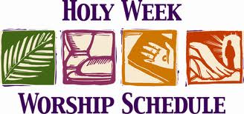

PALM SUNDAY: April 13th. Worship Service 10:00 a.m. with distribution of palms and the joining of new members.

MAUNDY THURSDAY SERVICE: April 17th: We will gather in the church sanctuary at 7:30 p.m. for our traditional candlelight service.

GOOD FRIDAY: April 18th

EASTER SUNRISE SERVICE: April 20th: On Easter morning there will be a Sunrise Service held at the Town Landing at 6:30 a.m. This will be an ecumenical service with St. Andrew’s By-the-Sea. Please dress warmly.

EASTER WORSHIP SERVICE: April 20th at 10:00 a.m.: This is a celebration of New Life. Everyone is welcome. Childcare will be available in the nursery for children up to age 5. An Easter activity packet will be available for older children to use during the Worship service.

COMMITTEE NEWS

For more information on any of the following committees, please contact the church office at
635-8472 or email Dawn at dawn@ucc.necoxmail.com

BOARD OF TRUSTEES

Board of Trustees
Ted Merriman,
Chair
The first Trustees meeting is scheduled for March 26th. At that time, we will have an opportunity for the new members (nearly half!) to introduce themselves to each other and settle in to business.

One of the first duties will be to review the church by-laws in order to fully understand the role of the team as well as the individuals in their designated capacity. Once grounded in our roles we will dive in to our duties of church business,

Many thanks to the Trustees that have moved on and a big welcome to the new members.

BOARD OF DEACONS

Deborah Kelchner,
Chair

The Board of Deacons of the United Congregational Church in Little Compton provides leadership to the Church’s ministry of serving the physical and spiritual needs of the members and friends of the Church. The principal mission of the Board of Deacons is to assist in the overall spiritual care of the congregation, including the pastor. In this capacity, the Board of Deacons interfaces with the various committees of the Church. The most visible way the Deacons serve is by being a scripture reader, greeting at the door before and after Sunday Worship, and preparing and serving Communion.

The Board of Deacons consists of 12 members, nominated by the Nominating Committee and elected by the Church membership at the Annual Meeting for a term of 3 years.


Kitchen Angels
Marsha LaPointe, Chair

Coordinated by Marsha LaPointe, the Kitchen Angels are a group of volunteers who cook wonderful and nourishing meals for anyone who may be recovering from surgery, is ill, or has a family member who is ill or recovering.

At these times, having a hot, home cooked meal delivered to the door can feel like a bit of a miracle. Certainly not having to even think or what may be for dinner is a burden lifted and when it arrives…hot and ready to eat...it is so very much appreciated.

For the Kitchen Angels, preparing and delivering that meal is a connection to helping a person or family who will benefit both physically and spiritually from that meal. It is a wonderful ‘give and take’ that becomes a manifestation of God’s love in our community.

If you would like to be on the volunteer list or know of someone who might need a home cooked meal, please call Marsha directly at 401 635-4520 (mcorgiville@aol.com).


Outreach Committee
Shirley Hardison & Marsha LaPointe, Co-Chairs

The Outreach Committee’s mission is to bring the works and spirit of our church to people in our own congregation, the Little Compton community and surrounding communities as well as people in other communities around the world.

This winter we have focused on our own congregation and the local community. Our annual Outreach Committee Pot Luck Supper was held in January. This was an especially nice evening this year as over 50 people gathered to share a wonderful array of homemade dishes to ‘warm’ our “tummies”, not to mention our souls, in the middle of this incredibly cold winter.

Every year we ask individuals from the organizations that we support to bring us an update on their organization. This year we heard from two organizations that we support with financial contributions: The Little Compton Wellness Center and The Little Compton Assistance Association.

Connie Castensen, President of the Friends of the Little Compton Wellness Center told us about an exciting array of activities and services offered at the Wellness Center ranging from podiatry clinics, wellness visits, and behavioral health services to meditation and yoga classes. We also heard from our own Sue Chase who told us about the services offered by the Little Compton Assistance Association (LCAA). The organization provides short-term emergency financial assistance for fuel, groceries, rent and utilities to individuals. Sue reported that the number of individuals and families who need help is growing.

On Saturday, March 15, several members of the Outreach Committee provided dinner to the Circle of Friends, a social gathering for teenagers and adults with disabilities that meets monthly at the Little Compton Community Center. The attendees loved the “Irish” stew, Irish soda bread, an elegant green jello salad and, of course, St. Patrick’s Day cupcakes. Dinner was followed by a very enthusiastic talent show put on by the attendees. Everyone on the Outreach Committee loves this event – the attendees are so appreciative of the home cooking, especially the desserts.


Search Committee
Hon. Paul Suttell, Chair,
Shirley Hardison, Secretary,
Cam Church, Chaplain

Your Pastoral Search Committee is off to a fast start. We’ve met twice since we were installed. In our first meeting we used a very interesting process directed by Rev. George Peters to select three leaders. As a result of that process, Paul Suttell will serve as our chairperson, Shirley Hardison will serve as the Secretary and Cam Church was selected to be our Chaplain.

In our second meeting, we were given a thorough ‘tour’ of the profile of the church that we will be creating during this phase of our work. By the end of that meeting, we were ready to start that process. Three groups were formed and have begun to work on separate sections of the profile. We also identified the information that we want to obtain from the members of the congregation.

Over the next weeks, the congregation will be given the opportunities on several occasions and in several different formats to provide input on a variety of topics needed to complete our profile. That information and the statistical data we gather will be compiled to form the very important profile that forms the foundation for our entire search process.

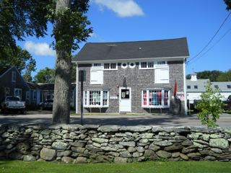
Thursday Thrift Shop
Donna Stewart

The Thursday Thrift Shop will open Saturday, May 3, 2014. Our goal is to serve the church, the community in a giving spirit, and extending the field of Christian charity in the name of the church. We are very grateful for the generosity of our many workers, consignors and the spirit of cooperation.



Sunday School
Heather Helger, Director of Children & Youth

This month in Sunday School the children were introduced to the Old Testament story of Abraham and Sarah through cooking, art, and games. In cooking class, children examined sand to realize how many descendants God promised Abraham, to recognize that with faith in God all things are possible by making sand pudding. In art class, children decorated a pillow case using fabric paint and star sponge stamps to help them remember that wherever they go, even if family is far away, to have faith that God is with them. Through games, the children were reminded to trust God to protect them and to give them the things they need.


PARENTS’ NIGHT OUT Fundraiser was a great success! Seven families had a great time out while the Youth Group entertained 14 kids. The youth group raised $210 with all proceeds benefiting The Relay for Life – American Cancer Society.

The Youth Group, “Faithful Doves”
will be participating in

the Aquidneck Island Relay for Life on Friday May 16th at the Gaudet Middle School in Middletown. The Youth Group will be working to create a world where cancer will no longer threaten our loved ones or rob anyone of another birthday. If you’d like to support the Faithful Doves, you can make a donation to the American Cancer Society and give your donation to Heather. The team’s goal is to reach $1,000! So far, the Faithful Doves have raised $450 dollars. With your help, we aren’t just fighting one type of cancer- we’re fighting for every birthday threatened by every cancer in every community. Thank you for your support!


Designer Spuds
On Sunday, April 6th at coffee hour, you can purchase a baked potato for $5 and design it to suit your taste using a variety of goodies from our topping buffet. We have ‘to-go’ containers available for those wishing to take it home. This is a Youth Group Fundraiser. All proceeds benefit the Relay for Life – American Cancer Society.

IMPORTANT: Please inform the church office if you know of anyone who may be in the hospital or if any member or friend has passed away. Also, please let us know if you know of any members who are planning to relocate.
Bells are ringing…

Passings – Members & Friends
Our sympathies to the families of:

Samuel P. Thomas
March 7, 2014 (M)

Everett ‘Tod’ Moore
March 19, 2014 (M)

Did you know?

The Thursday Thrift Shop opens on Saturday, May 3rd from 10am – 3pm?

That we have 54 people who are over 80 yrs. old in our membership?

As of April 1st, there are only 103 days left until Fair Day?

You can’t sneeze with your eyes open?

April's Full Moon, Full Pink Moon, heralds the appearance of the moss pink, or wild ground phlox—one of the first spring flowers. It is also known as the Sprouting Grass Moon, the Egg Moon, and the Fish Moon.

Rev. Sue’s favorite holiday is April Fool’s Day?

We are still receiving pledge cards?

Our deadline for the next newsletter is Tuesday, April 22nd.

A Blast From the Past!

Marjorie Simmons, Church Historian

Mix & match the celebrities below with the dates they were featured at our Summer Fair.

1969 Rex Trailer & Pablo

1970 Emmett Kelly, Jr.

1963 David Brinkley

1969 Col. John H. Glenn, Jr.

Q: Last month, we asked: In 1961, we had three clubs…The Look-Out Club, The Pilgrim Fellowship, and the Richard Billings Club. Can you tell us what they were about?:

A: The Look-Out Club was for the junior group of our church. They enjoyed many activities and outings. The Pilgrim Fellowship was for the senior group of our church. They had special outings and programs. They also helped at the Summer Fair. The Richard Billings Club was formed for social fellowship for adults. This club was responsible for the annual Sunday School Picnic. Their money-making projects were the May Breakfast and the Harvest Supper.

Bulletin Bloopers

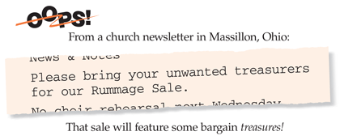

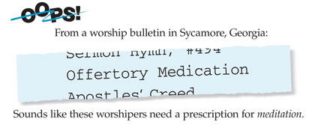

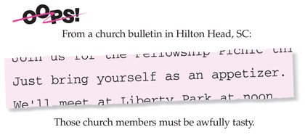

Coming in Our Next Issue…

•Committee News
•Fair News
•Our New Members
•Bible Jokes
•More Blasts from the Past
•Children’s Page

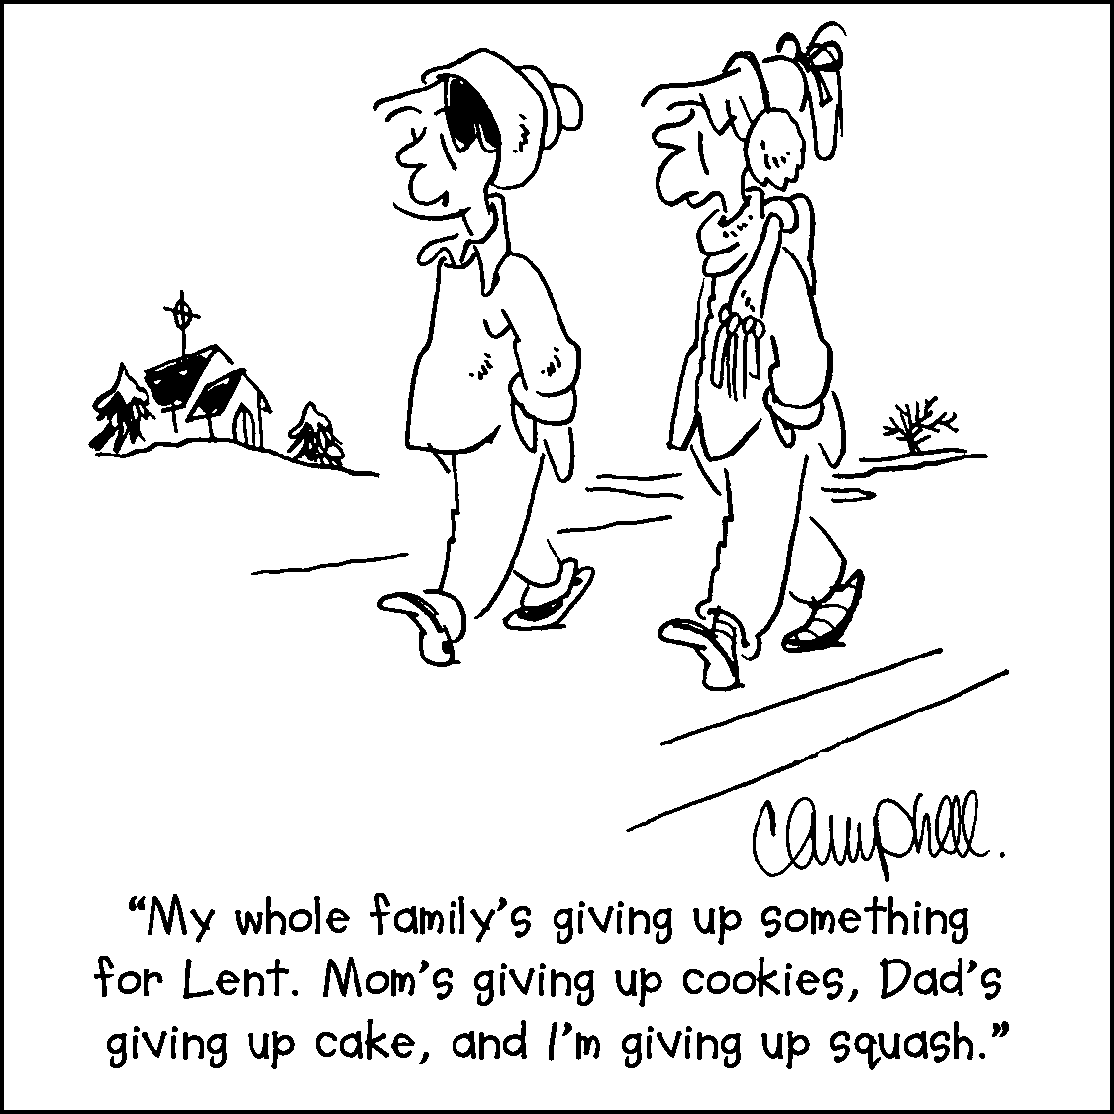







Copyright ©1996-2014 by Communication Resources. All rights reserved. The Newsletter Newsletter® (ISSN 0885-6966) is published monthly by Communication Resources, Inc.,
PO Box 36269, Canton, Ohio 44735, Phone: 1 800 992-2144,
Materials may be republished only in subscribers' own parish publications. No portion may be reproduced in any form for resale or redistribution.

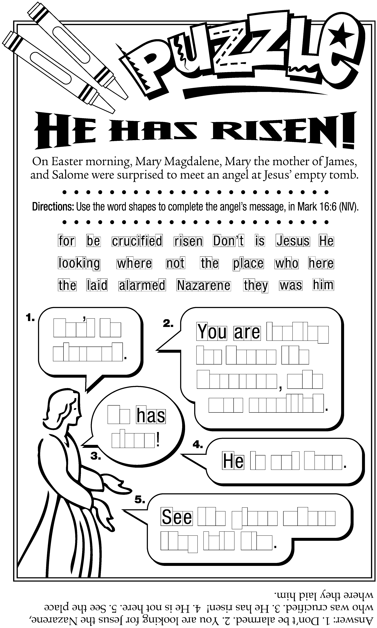
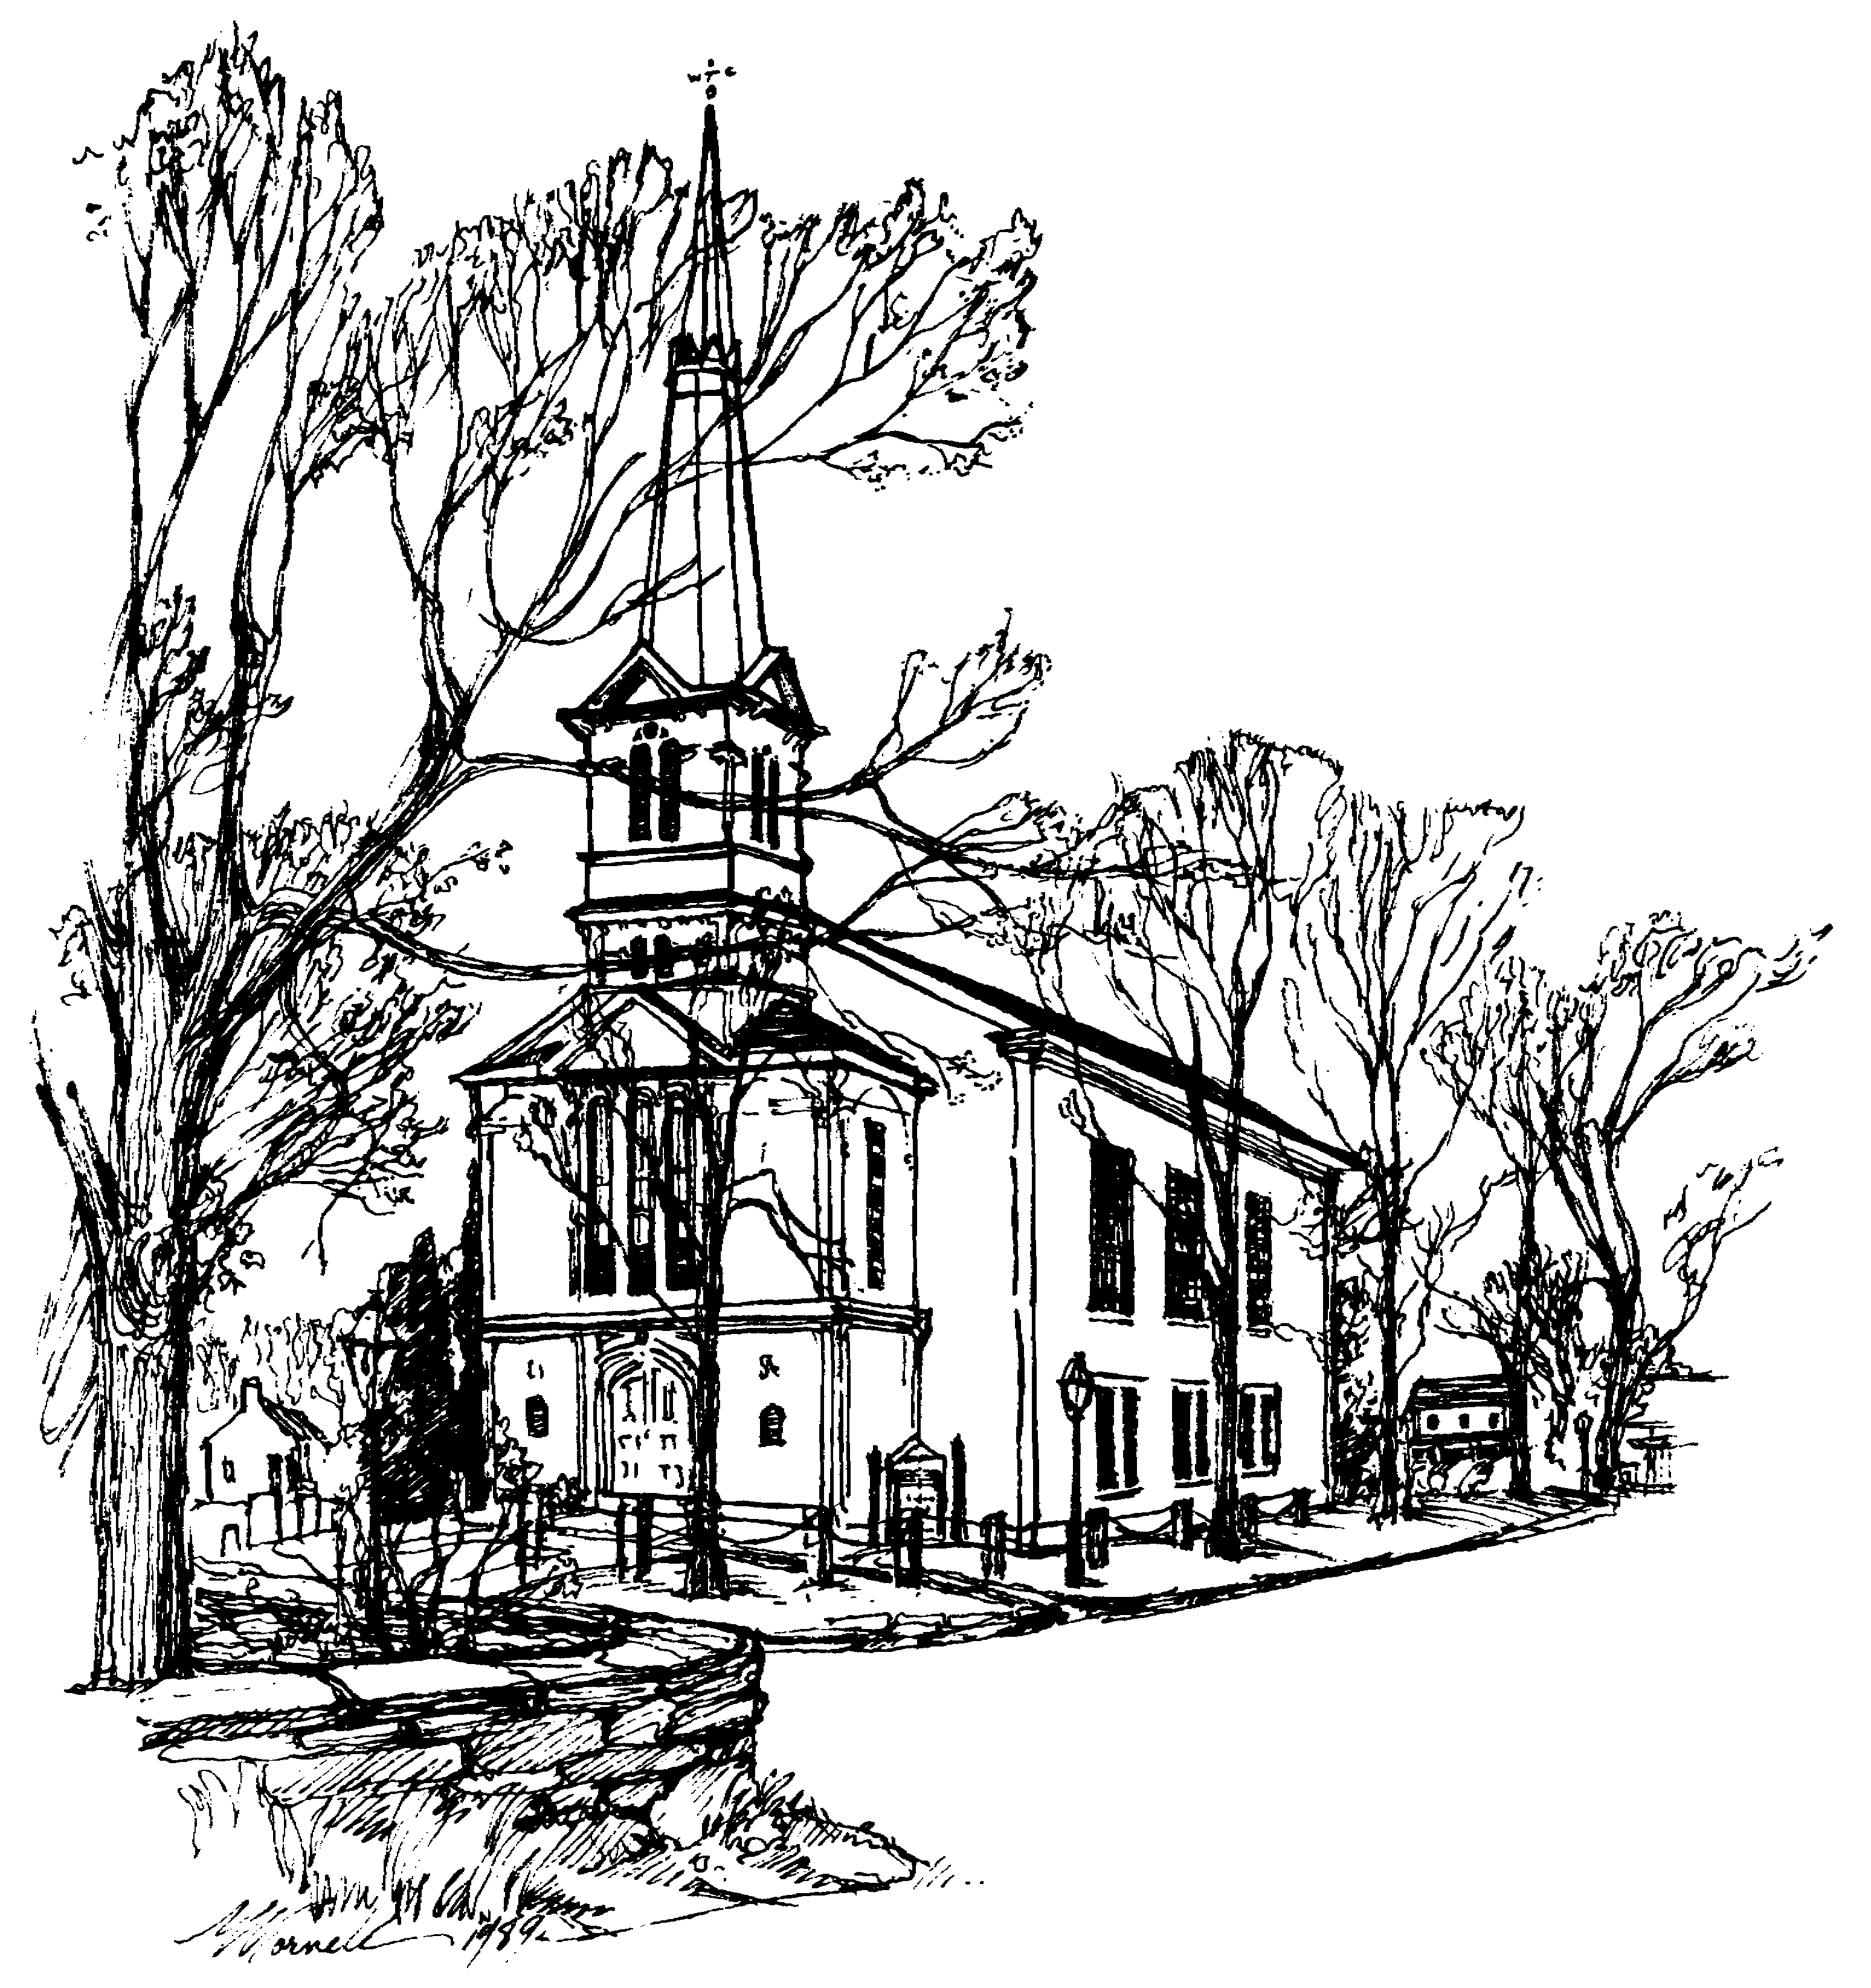 | UNITED CONGREGATIONAL CHURCH  The Commons  P.O. Box 506  Little Compton, RI 02837  Return Service Requested | 

UNITED CONGREGATIONAL CHURCH STAFF
Tele: 401-635-8472 Fax: 401-635-8473
Website: www.ucclcri.org

Interim Senior Minister – Rev. Susan O. Remick revsue@ucc.necoxmail.com
Church Secretary – Dawn Ross dawn@ucc.necoxmail.com
Church Bookkeeper – Maureen Cook bookkeeper@ucc.necoxmail.com
Director of Children & Youth – Heather Helger ssfaithful@ucc.necoxmail.com
Music Director – Michael Bahmann
Junior Choir Director – Stephanie Derbyshire vtderby1@cox.net
Service Coordinators – Janet Lofsky janetlofsky@aol.com
Heather Helger ssfaithful@ucc.necoxmail.com
Parish Nurses – Wendy Merriman WHMerr@aol.com
Annie Ellis 508-679-5381

