The Church Bell

United Congregational Church
The Commons
P.O. Box 506
Little Compton, RI 02837
Telephone 401-635-8472
Fax 401-635-8473
Office Hours:
Tues – Fri, 9 AM – 3 PM

Worship Service:
Sundays at 10 AM

Email: dawn@ucc.necoxmail.com
Web Site: UCCLCRI.org


2015

INSIDE THIS ISSUE

Chiming In…A message from Rev. Sue

Committee News

Holy Week Schedule

Bells Are Ringing…(Baptisms,
Weddings, Passings)

Did you know?

Shortcut Carrot Cake Recipe

Blast from the Past

Bible Trivia

Musica Maris Schedule

Children’s Craft and Puzzle

What’s Happening? April/May Calendar

Chiming in…

Recently, my family gave me a Kindle. A Kindle is, in simplistic terms, a portable, small computer that you can carry with you. Now people have I-Pads and other gadgets, and books can be downloaded onto these electronic miracles. Now you can read on a device that is only 1/2” thick. What an amazing thing!
I do not have much time for personal reading but when I do, I like the feel of having a book in my hands. This technology took some getting used to. Now I bring it with me often, especially when I have to wait somewhere, but I still get
real books too! Have you seen my library?
One of my favorite things about reading is to be able to turn the page. On the Kindle, you can swipe your finger across and the page turns. It even has sound effects.
Sometimes I turn the page with trepidation. I do not want to read what is coming next. Sometimes I can’t turn the page fast enough. Surely the bad stuff that has happened is going to get resolved or will it get worse? No matter what is coming, it is sure to be an adventure!
When I am not reading, I am often watching Disney movies with my granddaughter. I have enjoyed watching them with her as she gets to know
these young heroines. In the movie Pocahontas, I particularly like the song where Pocahontas is trying to decide if she should marry the Indian warrior or go with Captain John Smith. She is in a canoe and as she paddles, she wonders “what’s around the river bend?” She wonders about the adventures that lie ahead? That is what it is like to read a great story. That is also what it is like in life.
The pages turn slowly at times and at other times they turn all too quickly. We wonder what is around the bend as we turn the corner or face our next chapter. When will the winter weather end? When will the dark days turn into summer evenings? When will our pain get resolved? Is there more pain to come? How will it all end?
In the season of Lent, we pause to think about our adventures as people of faith. When our celebration of Easter arrives, we turn the page from the darkness of Lent. Easter marks for us a new day, a new chapter, a new adventure, and a new hope. Because of this Easter story, we are emboldened to turn each page in hope and trust for no matter what lies ahead, we will not face it alone. May your future be filled with adventure of the most positive kind and may this new season of hope fill you with promise and joy.

Rev. Sue

~IMPORTANT~

If you have a pastoral emergency, and cannot reach Rev. Sue through the office, you may call her at 781-724-9831, or call Deacon Debbie Kelchner at 401-524-2007.

BOARD AND
COMMITTEE NEWS

For more information on any of the following committees, please contact the church office at
635-8472 or email Dawn at dawn@ucc.necoxmail.com

Board of
Deacons

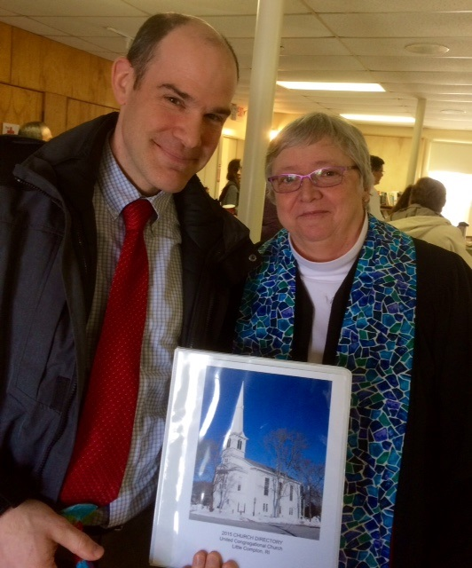

Debbie Kelchner, Chair

Congratulations to our own
seminary student in
discernment, Amy Edwards, who was approved for Ordination, upon graduation and receiving a call, by her Ecclesiastical Council. On March 8th many from our congregation were in attendance at Amy's Ecclesiastical Council which was held at our Church. Amy presented a synopsis of her Ordination Paper and answered questions from the council and attendees. The council then voted unanimously to approve her candidacy for ordination. The Hospitality Committee hosted a lovely reception afterwards to help Amy celebrate this wonderful accomplishment.

The new church directory is finished! After over 2 years of preparation and many hours of work, the final product is available. Special thanks to Charlie Thomas for researching various software programs and collecting data. Also, big thanks to Dawn Ross and Rev. Sue for their hard work in getting this big task done. The loose leaf format allows for additional picture pages to be added and the printed information to be updated as needed. So those who still want their picture to be included at a later date, please submit your picture to the Church Office. If you have not picked up your directory which has been available in the vestry after services, please contact the office to obtain your copy. A donation of $10 is requested to cover the cost of printing.

Charlie Thomas & Rev. Sue
Bells are ringing…

Baptisms
A warm welcome from our church family to:

Anne Haverland Morley
Daughter of Andrew James Morley and Laura Haverland. Baptized on March 15, 2015.

We would also like to extend a warm welcome to Cameron Clark, Paul Golembeski, and
Bill Ryan who are scheduled to become new members this Sunday, March 29th!



April 2nd – Maundy Thursday Service, 7:30 PM

April 3rd – Good Friday. Confirmation Class (T-LC Group) – Stations of the Cross at Holy Trinity in Tiverton, 12:00 PM

April 5th – Easter Sunrise Service at Town Landing, 6:30 AM

April 5th – Easter Service,
10:00 AM

Board of Trustees

Ted Merriman, Chair

The Trustees are busy collecting information to provide to the congregation at the next Quarterly Meeting. We hope to have updates and healthy discussion around the sprinkler system, kitchen and parsonage projects. The date of the meeting will be announced shortly. A reminder that approved minutes of Trustees meetings are posted in the vestry as well as being available from the office.

Our deadline for the
May Newsletter is
Friday, April 17th.

Finance Committee

Bob Hartnett, Chair

With this winter being one of the coldest and snowiest months that we can remember it wasn’t kind to everyone who witnessed it first-hand. It also had an impact on the Church finances with service being canceled due to the snow on a few occasions as well as the cold weather keeping some at home. Spring is finally here and for everyone’s sake the warmer weather will soon be too. Let us pray.

Health & Wellness Ministry / Shawl Ministry

Pam Church, Chair

Spring has sprung!! Now that the weather has become more temperate…spend time outside in nature to enjoy the benefits of the season!

Being outside in nature can have many positive effects, from reducing anger, fear and depression to increasing our psychological wellbeing and happiness. When we spend time outside, whether it is in the woods, at the beach, in the field or in our gardens, nature is enlivening us. All around us there is beauty and wonder if we take the time to see it. We are moved by the beauty we see; we are soothed by the sounds we hear. Nature brings us out of ourselves and our own concerns and connects us to the greater world.

Spend time outside to support your physical, emotional and spiritual health!

Members of the Health and Wellness Ministry continue to be available for the congregation for information on our Shawl Ministry, Library Cart, Community Wellness, and Bereavement.

Health & Wellness
Committee Members:

Bereavement - Judith Anderson
Shawl Ministry - Pam Church
Library Cart - Karen Corrigan
Community Outreach - Susan Chase
Nutrition - Ministry
Other Health Concerns - Wendy Merriman

Sunday School

Heather Helger
Director of Children & Youth

S.S. Faithful

March’s Sunday
School rotation
story was “The Last Supper.” This was a great story to precede Easter. The morning of Children’s Church, just after hearing the story for the first time, I saw wonder and awe in the children’s eyes as they made the greater connection to the Communion ceremony we participated in afterwards! A God moment for sure! The following three weeks, the children participated in the following workshops:

ART: Children made decoupage wine glasses with tissue paper and placed a copy of The Great Commandment inside as a reminder that when we drink the cup and eat the bread we are to remember we have a special relationship with Jesus and that this means we should always try our best to remember to live and behave in a manner that confirms this relationship.

DRAMA: Children acted out the story of The Last Supper by participating in a simplified version of a Seder experiencing when in the meal Jesus broke the bread and shared the cup, an effort aimed to create a real connection to this event. At the end, we also shared elements far from bread and grape juice eliciting a fun discussion reinforcing the fact that it’s not the elements that make communion sacred; it’s the Spirit in our hearts.

COOKING: Children made and tasted unleavened bread (like the kind Jesus and his disciples would have eaten at the Passover meal from our story) and then brought some home in order to share with their family at dinner. They learned communion means “sharing,” and were encouraged to share the story of The Last Supper and what they learned from it at home with their families while sharing the unleavened bread.

The toddlers in the nursery focused on the fact that during the Last Supper, Jesus gave us a way to remember him, through activities which included

Play-doh, a puzzle/coloring and a remembering game.

The Youth Class focused on the life of Jesus this month and watched the movie “Jesus of Nazareth.”

Reminder: NO SS workshops Easter Sunday, enjoy the service as a family. There will be an “Easter cross” craft option available for interested children, held downstairs in the vestry after the Children’s Message during the remainder of the service.

Youth Group

Being in the season of Lent, we focused Youth Group meetings appropriately. The first meeting of the month, we participated in a “Praying in Color” activity. If you are interested in learning more about this technique, check out the book: “Praying in Color” by Sybil MacBeth, there is both and adults’ and kids’ version available. The second meeting of the month, we had lots of fun playing Easter Jeopardy, while learning some of the more obscure events of this very important event of our faith.

Confirmation Class

If you attended worship on March 22nd, you saw four members of our current Confirmation class help Pastor Sue deliver parts of the service and heard her share their prayer experiences of asking God for help. One other confirmand led the Call To Worship on March 8th and there will still be another Sunday in which a final confirmand will participate as well. This all came out of a lesson to help them learn about worship. Their second lesson this month focused on discipleship. They learned how being a disciple is like being a part of our church team and they also even learned some of the details of the lives of Jesus’ disciples and apostles. Do you know the difference between a disciple and an apostle?

Upcoming Event


Stations of the
Cross Walk ~
Good Friday, April 3rd at Holy Trinity Church in Tiverton at noon. Please feel free to join our Confirmation Class and Youth Group for this meaningful event.



Thursday Thrift Shop
Nancy Webb

The Thursday Thrift Shop will begin accepting consignments and donations of clothing and articles on Monday, April 6 from 1–3:00pm, and will continue each Monday throughout April. Beginning Saturday, May 2, opening day for the thrift shop, items are accepted from 10–12:00pm each Saturday as well.

Please bring no more than four boxes of donations at a time, and items need to be clean, seasonal and appropriate for resale. Winter items will be accepted beginning August 2.

Shirley Hardison is assisting Thrift Shop Manager Anne Tillinghast this year, and Pooka Truslow will continue to schedule volunteer workers and send out monthly shift time notices.

Thrift Shop hours are Thursday and Saturday, 10:00am to 3:00pm. The Thursday Thrift Shop is looking forward to another successful year and greatly appreciates church and community volunteers and donations.

Office News


THE NEW CHURCH
DIRECTORY IS
HERE! If you are
listed (even if you didn’t get your picture in), the Deacons will be handing them out after church or you can pick one up at the church office. Limit 1 per household. We will start a sign-up list for those who did not get in. We will be asking for a voluntary donation of $10 to help defray the cost of printing.

IMPORTANT

Please inform the church office if you know of anyone who may be in the hospital or if any member or friend has passed away. Also, please let us know if you know of any members who are planning to relocate.

Please feel free to fill out a yellow KEEP IN TOUCH card (KIT) [which can be found in the pews] if you need to update your
information with us and place them in the offertory plate.



The United Congregational Church is excited to announce that you can now manage your giving online! Giving online is easy and allows you to set up automatic recurring contributions and view your complete online giving history from anywhere you have access to the Internet.

● Visit the church website at
www.ucclcri.org


DO YOU HAVE
A FEW
MINUTES FOR
PRAYER?

Our next time together will be on SUNDAY, APRIL 19TH in the Parish House Conference Room from 11:30am – 1:00pm.

Last Scheduled Class
Sunday, May 17th

We hope to see you at our next gathering! All are welcome!
Coming in Our Next Issue…

•Committee News
•More news and fun
•Blasts from the Past
•Children’s Page
•May/June Calendar


MUSICA MARIS

THE BEST OF
THE REST

No Mozart this time

Chamber Music by Hummel, Pleyel, Schobert Et Al

Sarah Darling ~Violin
Reinmar Seidler ~ Violoncello
Michael Bahmann ~ Fortepiano

SUNDAY, APRIL 26TH, 2015
4:00 PM

ALL CONCERTS AT THE
UNITED CONGREGATIONAL CHURCH
LITTLE COMPTON, RI

SUGGESTED DONATION $20
FOLLOWED BY RECEPTION

A Blast From the Past!

Marjorie Simmons, Church Historian

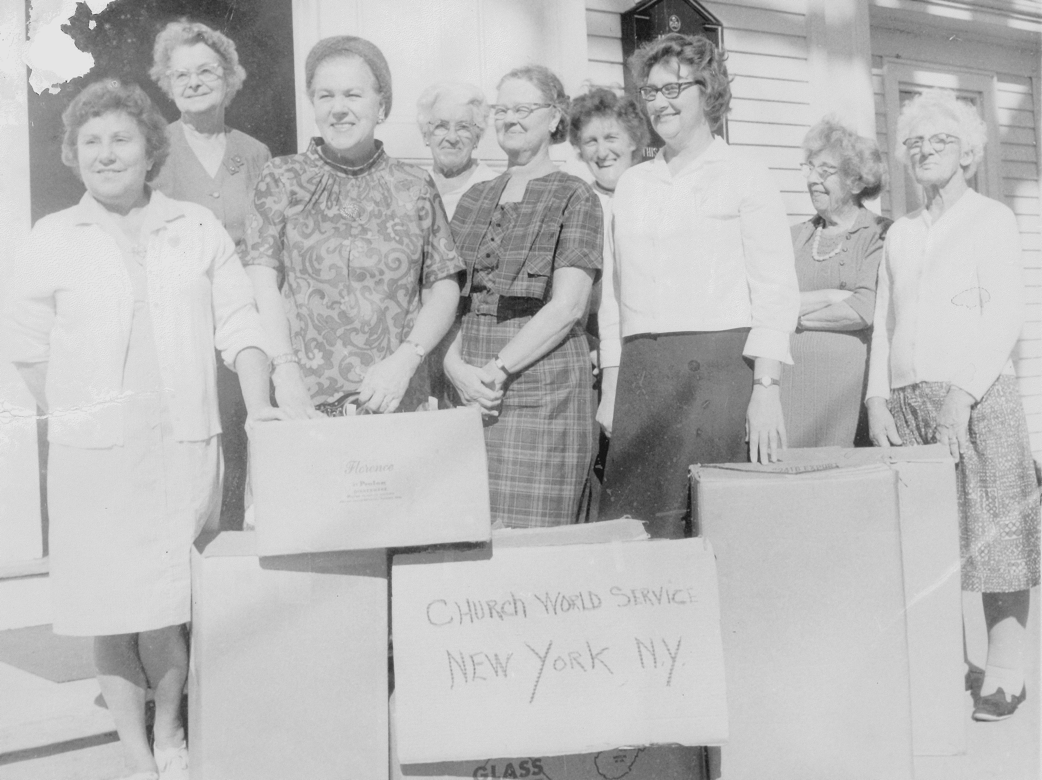

Back Row: Hope Shurtleff, Gladys Wordell, Mabel Frankland, Mabel Sowle. Front Row: Isabel Grinnell, Edith Snell, Elsie Hathaway, Ellie Silveira, & Vivian LeBeau

Members of the Ladies’ Aid Society gathered items to donate to Church World Service.



Easter morn with lilies fair
Fills the church with perfumes rare,
As their clouds of incense rise,
Sweetest offerings to the skies.
Stately lilies pure and white
Flooding darkness with their light,
Bloom and sorrow drifts away,
On this holy hallow’d day.
Easter Lilies bending low
In the golden afterglow,
Bear a message from the sod
To the heavenly towers of God.

~ Louise Lewin Matthews




Copyright ©1996-2014 by Communication Resources. All rights reserved. The Newsletter Newsletter® (ISSN 0885-6966) is published monthly by Communication Resources, Inc., PO Box 36269, Canton, Ohio 44735, Phone: 1 800 992-2144, Materials may be republished only in subscribers' own parish publications. No portion may be reproduced in any form for resale or redistribution.

Bible Trivia
Stones, Rolling and Nonrolling

How many of the following can you answer? (Answers in next month’s newsletter).

- Who used a stone for a pillow?
- Who rolled the stone across the tomb when Jesus was buried?
- Which disciple was called a rock?

Why We Celebrate

Jesus is a redeemer, a restorer in every way. His day on the cross looked like a colossal failure, but it was his finest moment. He launched a kingdom where the least will be the greatest and the last will be first, where the poor will be comforted and the meek will inherit the earth. Jesus brought together the homeless with the privileged and said, “You’re all poor, and you’re all beautiful.”

The cross leveled the playing field, and no earthly distinction is valid anymore. There is a new “us” – people rescued by the Passover Lamb, adopted into his family and transformed into saints. It is the most epic miracle in history. That is why we celebrate. ~ Jen Hatmaker, 7: An Experimental Mutiny Against Excess





Did you
know?

When taking a bite into a chocolate bunny, 76% of Americans prefer to bite off the ears first!

Eggs contain nearly every nutrient known to be essential to humans.

The Easter Lily is native to Japan.

The Easter Lily symbolizes purity, life, & renewal.


Shortcut
Carrot Cake
(Kraft Recipes)

Ingredients:
1 pkg. (2-layer size) spice cake mix
3 large carrots, shredded (about 2 cups)
1 can (8 oz) crushed pineapple in juice, drained
1 cup chopped PLANTERS Pecans, divided
2 pkg. (8 oz. each) PHILADELPHIA Cream Cheese,
softened
2 cups powdered sugar
1 tub (8 oz.) COOL WHIP Whipped Topping,
thawed

Directions:
Heat oven to 350 deg. F.

Prepare cake batter as directed on package; stir in carrots, pineapple, and ¾ cup nuts. Pour into 2 (9 inch) square pans sprayed with cooking spray.

Bake 25 to 30 min. or until toothpick inserted in centers comes out clean. Cool cakes in pans 10 minutes. Invert onto wire racks; gently remove pans. Cool cakes completely.

Beat cream cheese and sugar in large bowl until blended. Whisk in COOL WHIP.

Stack cake layers on plate, spreading frosting between layers and on top and sides of cake. Sprinkle with remaining nuts.

PREP TIME: 30 min.
TOTAL TIME: 1 hr. 30 min
SERVINGS: 16

April showers bring May flowers,
That is what they say.
But if all the showers turned to flowers,
We’d have quite a colorful day!


 | UNITED CONGREGATIONAL CHURCH  The Commons  P.O. Box 506  Little Compton, RI 02837  Return Service Requested | 



Happy Easter!

UNITED CONGREGATIONAL CHURCH STAFF
Tele: 401-635-8472 Fax: 401-635-8473
Website: www.ucclcri.org

Interim Senior Minister Rev. Susan O. Remick revsue@ucc.necoxmail.com
Church Secretary Dawn Ross dawn@ucc.necoxmail.com
Church Bookkeeper Maureen Cook bookkeeper@ucc.necoxmail.com
Director of Children & Youth Heather Helger ssfaithful@ucc.necoxmail.com
Music Director Michael Bahmann
Junior Choir Director Stephanie Derbyshire vtderby1@cox.net
Service Coordinators Janet Lofsky janetlofsky@aol.com
Karen Carneal Kcarneal7@cox.net

APRIL 2015
Sunday | Monday | Tuesday | Wednesday | Thursday | Friday | Saturday
29  Designer Spuds!  NEW MEMBER SUNDAY  10:00 AM Worship Service  11:15 AM Shawl Ministry  4:00 PM Musica Maris | 30 | 31  7:00 PM Adult Choir | 1 | 2    3:00 PM Junior Choir  7:30 PM Maundy Thursday Service | 3    12:00 PM Confirmation Class - T-LC Stations of the Cross at Holy Trinity | 4
5    There is no Shawl Ministry today  There is no Sunday School today  6:30 AM Easter Sunrise Service at Town Landing  10:00 AM Easter Worship Service | 6 | 7    7:00 PM Adult Choir | 8 | 9    3:00 PM Junior Choir  6:00 PM Deacons | 10 | 11
12    Communion Sunday  NO YOUTH GROUP  10:00 AM Worship Service  11:15 AM Shawl Ministry  11:20 AM Confirmation Class | 13 | 14  7:00 PM Adult Choir | 15 | 16    3:00 PM Junior Choir  7:00 PM Religious Ed | 17   | 18
19    Baptism "Appleton"  Guest Preacher, Rev. Beverley Edwards  There is no Sunday School today  10:00 AM Worship Service  11:15 AM Shawl Ministry  11:30 AM "ECP" Prayer Group | 20 | 21    10:00 AM Visiting Committee  6:30 PM Finance Committee  7:00 PM Adult Choir | 22    6:30 PM Trustees | 23  3:00 PM Junior Choir | 24 | 25    8:00 AM Men's Breakfast Group
26    10:00 AM Worship Service  11:15 AM Shawl Ministry  11:30 AM Potluck lunch for New Members & Leadership  4:00 PM Musica Maris | 27 | 28    11:30 AM Staff Meeting  7:00 PM Adult Choir | 29 | 30  3:00 PM Junior Choir  6:00 PM Confirmation Mentor Dinner | 1 | 2  THRIFT SHOP OPENS!

MAY 2015
Sunday | Monday | Tuesday | Wednesday | Thursday | Friday | Saturday
26  10:00 AM Worship Service  11:15 AM Shawl Ministry  11:30 AM Potluck lunch for New Members & Leadership  4:00 PM Musica Maris | 27 | 28  11:30 AM Staff Meeting  7:00 PM Adult Choir | 29 | 30  3:00 PM Junior Choir  6:00 PM Confirmation Mentor Dinner | 1 | 2    THRIFT SHOP OPENS!
3    Communion Sunday  CONFIRMATION SUNDAY  10:00 AM Worship Service  11:15 AM Shawl Ministry | 4 | 5  7:00 PM Adult Choir | 6 | 7  3:00 PM Junior Choir  7:00 PM Religious Ed | 8 | 9
10    No Shawl Ministry today  10:00 AM Worship Service | 11 | 12  7:00 PM Adult Choir | 13 | 14  3:00 PM Junior Choir  6:00 PM Deacons | 15 | 16
17    10:00 AM Worship Service  11:15 AM Shawl Ministry  11:30 AM ECP Prayer Group | 18 | 19  10:00 AM Visiting Comm.  6:30 PM Finance Comm.  7:00 PM Adult Choir | 20 | 21    3:00 PM Junior Choir | 22 | 23
24    Guest Preacher  10:00 AM Worship Service  11:15 AM Shawl Ministry | 25   | 26  7:00 PM Adult Choir | 27  6:30 PM Trustees | 28  3:00 PM Junior Choir | 29 | 30
31  Baptism "Bloom"  Quarterly Meeting  10:00 AM Worship Service  11:15 AM Shawl Ministry | 1 | 2 | 3 | 4  7:00 PM Religious Ed | 5 | 6

