The Church Bell

United Congregational Church
The Commons
P.O. Box 506
Little Compton, RI 02837
Telephone 401-635-8472
Fax 401-635-8473
Office Hours:
Tues – Fri, 9 AM – 3 PM

Worship Service:
Sundays at 10 AM

Email: dawn@ucc.necoxmail.com
Web Site: UCCLCRI.org


2015

INSIDE THIS ISSUE

Chiming In…A message from Rev. Rebecca

Committee News

Christmas Eve Services

Christmas Poinsettia Form

Children’s Coloring Page

What’s Happening?
●Children’s Christmas
Pageant
●Christmas Caroling
● Office Holiday Hours
● December/January
Calendar

Chiming in…

Dear Brothers and Sisters of United Congregational Church,

We have entered the holy season of Advent. The word “Advent” is from the latin word “Adventus” meaning coming, approach, or arrival. And so in these four weeks leading up to Christmas we prepare and wait for the coming of Jesus. It is a season pregnant with expectation, full of watchful anticipation; our eyes are trained on a dark horizon but the dawn has not yet appeared.

In a culture run on instant gratification, where the media promises us that our heart’s desire is just one click away, it is a strange and counter-cultural thing to dwell in the waiting. But in Advent, that is exactly what we do. We can’t rush this birth, can’t overnight deliver the Christ-child. So we slow it down and wait. We light one candle at a time. We watch each Sunday as the manger fills with Oxen and sheep, then shepherds and angels, then Mary and Joseph, all waiting. While we wait, we listen and hope with the world for peace and joy to break into our lives. We prepare room in our hearts for the One who comes to unlock our hearts, to turn them toward the light, to teach them to forgive as we are forgiven. There is something beautiful and transformative in the waiting.

So this Advent Season, let’s wait together. Let’s gather together to tell the old stories of an ancient people waiting with hope for their God to arrive. Let’s remember together Mary's extraordinary journey and let's wait by her side to see the fulfillment of the promised birth. Let’s sing the Advent carols together. Let’s sink deep into the waiting, letting the mystery and darkness wash over us, and the seeds of hope plant in our hearts.

Grace and Peace,

Rev. Rebecca Floyd Marshall

~IMPORTANT~

If you have a pastoral emergency, please contact us so we can be there for you! During office hours (Tues-Friday, 9am-3pm), please call the church office at (401) 635-8472 to reach Rev. Rebecca. If you have a pastoral emergency outside of office hours, please contact Head Deacon Debbie Kelchner at 401-524-2007.

BOARD AND
COMMITTEE NEWS

For more information on any of the following committees, please contact the church office at
635-8472 or email Dawn at dawn@ucc.necoxmail.com

Board of
Deacons

Catherine Sawoski, Youth Deacon

ADVENT

There has never been a time when advent hasn’t been celebrated at the United Congregational Church of Little Compton, as a time that honors the birth of Jesus Christ, and the way that he lived with love and peace. Through events such as pageants, caroling, and wreath building, we open up our community and embody the very traits that are exemplified around the holiday season. However, Advent wasn’t always the time we view it as today, although it was consistently said to have roots in the birth of Jesus.

It has always been contested the exact origins, but members of the Catholic Church say that St. Peter was responsible for this celebration of the coming of Christ, as he is widely considered the first pope. With this power over a faith he established an official time for repentance, so that the members of the church would be ‘pure’ for the baby’s arrival each year. In some factions of the church, advent and lent are closely related to the point that advent is the same penitential season, just less strict than the time leading up to his death. Others say that it was started a good deal later by an organization called the Council of Tours, which was the first foundings of the church located in the city of Tours because Rome has been mostly converted to strict Catholicism. According to this theory, a group of monks - or disciples, depending on the source - were told to fast for thirty days, for the same lead into the birth that the apostles were preparing for. However, the only thing that scholars can agree on is that there is no one clear founding of this tradition, but all evidence suggests that the underlying meaning is the buildup to Christ’s birth, in the planning of the arrival and the start of the new church year.

In the majority of Christian churches, advent means the lighting of four candles in a wreath; one every Sunday leading up to Christmas services. While this may seem like a custom to those in the UCCLC, compared to other Christmas practices it has the most recent origins in North America, from after even the Christmas tree. Similarly to how these trees are and were commonly made of fir, so is the traditional advent wreath. In the 19th century, there used to be 24 candles leading up to the 25th of December, but soon they realized it was a hazard and precarious to light one each day, so they made the switch to the customary four. These developed into the meanings that each one symbolize: hope, love, peace, joy, and a candle at the center representing Christ. Purple is the color of advent, which is why all the candles are purple, except the third candle is pink to represent JOY. The Christ Candle in the center is usually white, a sign of eternal life. This portrays not only how he is a representation of all of these essential traits, but how those participating in the season should use that time to embody them, shown in how to minister will wear the color purple for all of those values. This example of a commitment over the holiday season is a beautiful reminder, and the UCCLC always has an opportunity for families to make their own to light just as is done in church.

The advent season calls for a host of activities in our church other than the wreath-making, including the Christmas Pageant by the children, led by Youth Director Heather Helger, and confirmed youth co-director Sam Ryan. After rooting through scripts and propositions for the performance this year, they settled on the topic of letters that been sent to Jesus, by young kids asking him about the season. It’s scheduled in place of Rev. Rebecca’s sermon on December 20th. Following the service that day will be Christmas caroling, at 3:00p.m. Members of the congregation will meet at the church and ride a rented bus to the houses of those who aren’t able to make it to church, whether it be due to illness, tragedy, or anything else affecting their life.

Advent has always been a time for celebration the church, and in the UCC of LC it means a particularly eventful season for activities pertaining to the holidays. While the exact origins of this special time are known, it does not change the meaning that has been carried across centuries: the preparation of Christ’s arrival into the world. This also shines through in the tradition of the advent wreath, as the lightings of the candle signify what Christians try to convey: love, peace, joy, hope, and the spirit of Christ himself. And as we participate in all of the joyous times ahead; let us carry these traits with us.

Board of Trustees

Tom Schmitt, Chair

It is that time of year when the church Nominating Committee develops a slate of officers, deacons and trustees to be considered by the congregation for election to terms that will begin at the February 28th Annual Meeting. One might ask, “What’s the Nominating Committee; who’s on it; and for what positions do they prepare a slate of candidates?” Good questions! Participation on the Nominating Committee and its responsibilities are defined in our By-Laws. Organized by the Board of Trustees, the Nominating Committee
determines which positions will need to be filled for terms beginning in 2016, and then meets to identify church members who may be asked to volunteer to serve as an officer or board member. Nominating Committee members include the Pastor, the current and previous chairs of the Board of Trustees, the current and previous chairs of the Board of Deacons, the Church Historian, the chair of the Membership Committee and two at-large members.

The Nominating Committee is responsible for preparing a slate of candidates for all officer positions (Chair of the Board of Deacons, Chair of the Board of Trustees, Moderator, Secretary, Chair of the Finance Committee, Treasurer and Chair of the Buildings and Grounds Committee). The Committee also nominates members for election to three-year terms on the Board of Deacons and to fill three-year terms as At-Large members of the Board of Trustees. If you want to volunteer for or suggest a nominee to any of these positions, please contact Reverend Rebecca or me.

We are recruiting members to serve as delegates to the Rhode Island Conference of the United Church of Christ, which is in the process of assessing its organizational future. Our Church, entitled to eight voting delegates, wants to assure active participation in that important discussion and decision-making process. If you want more information about or are interested in serving as a delegate, please contact Debbie Kelchner, Chair of the Board of Deacons.

Each year the church engages an independent Accountant to review church finances—sort of like an audit required of most formally organized business entities. Most years that financial review has concentrated on the processes we use to track operating income, expenses as well as our physical (buildings and equipment) and financial (endowment investments) assets. In an effort to understand the broader picture of our church finances and plan accordingly, Sue Hutson, Treasurer and Bob Hartnett, Chair of the Finance Committee, have asked our Accountant to review all church activities and components that oversee and/or perform financial transactions or account for them. The purpose: to study and document how we manage and account for our financial resources and to learn ways we can strengthen and improve those processes.

Thanks to all who visited the Parsonage when it was open in early November following Sunday church service. I am happy to report it is now rented. We are working to finalize renewal of our lease of steeple space to AT&T for cellular communications antennas. We also hope soon to finalize an underground utility easement with a neighbor to the southwest of the Thrift Shop.
Finance Committee

Bob Hartnett, Chair

As we approach the end of 2015, Finance would like to thank everyone for their pledge and gifts throughout the year. Without you our splendid Church would not be what it is today. We saw many changes and continue to have a very welcoming, hardworking and generous Congregation. I should add resilient. With Rev. Rebecca in full swing we are seeing the pews come to life on Sundays. God is indeed looking after us. We would also like to thank the entire staff. They do not get enough credit and it is a pleasure working with everyone. If you haven’t visited recently I urge you to. You will know what I mean when you do. We are very fortunate.

Merry Christmas!

Flower Committee

Holly Billings, Chair

The Flower Committee is looking for a new monthly chairperson to see to the flowers in the church for the month of September. It is really easy and rewarding! Give me a call and I can explain the process. If you are interested in donating flowers, at any time, please see Holly Billings after church or contact her at 635-2451 or hgbillings@gmail.com

Junior Choir

Stephanie Derbyshire
Junior Choir Director
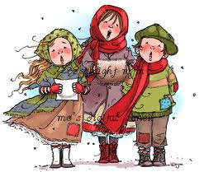

All-Church Christmas Caroling and light supper to follow. Please board the bus and join us for Christmas caroling as a church community on Sunday, December 20th from 3-5:30 p.m. Arrive at the church by 2:45...bus leaves by 3 pm! Soup and fresh bread will be provided immediately following the caroling in the church vestry. Stephanie and the Junior Choir will lead us in song as we tour the town of Little Compton caroling to the homes of individuals and families in need of Christmas love. Church members and families are highly encouraged to join us for a festive evening of neighborly Christmas cheer. What a great way for our church family to celebrate this Christmas season together so don’t miss out! Sign-up on the sheet posted in the vestry or call the Church office at 635-8472. Also, please call the office with suggestions as to who would enjoy a visit and we will do our best to accommodate! We will need this information by December 14th!!

Outreach Committee

Shirley Hardison & Marsha LaPointe
Co-Chairs


Donations are being accepted for our annual Christmas Food Baskets. In a cooperative effort, our church, St. Catherine and St. Andrews, the Little Compton Food Bank, and the Little Compton Wellness Center, will assemble and distribute food baskets to families throughout the community just before Christmas. The baskets will be filled with turkeys and all the fixings for holiday dinners and more. You can drop your contribution of non-perishable food items into the wagon downstairs on your way into church or mail a check to the church office at your convenience. Thank you from your neighbors in need.


Participate in the “Giving Tree”. Pick a gift label or two off the lovely tree that is inside the church door. Provide an unwrapped gift to the individual described on the label, “adult male”, “young girl”, etc. and place it back under the tree by December 18th. These gifts will be distributed to local people before Christmas. A good gift idea for hard-to-find people is a gift card valid for use at one of our local merchants.

Sunday School

Heather Helger
Director of Children & Youth
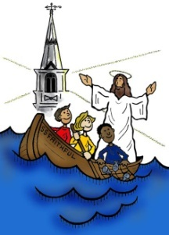
S.S. Faithful

Hoping your
Thanksgiving was
filled with God’s love and blessings! November was a month that S.S. Faithful can certainly be thankful for. The Sunday School rotation explored the story of Moses Parting the Red Sea. “God’s act of parting the Red Sea saves the Israelites from certain death and destruction. It gives them hope for a new life as the people of God and a new understanding of the power, compassion and faithfulness of God. Their response is great rejoicing. We too can rejoice that God is both powerful and caring. We can be glad that God keeps promises, and like Miriam, we can sing praises and rejoice! Like Miriam and all who crossed the sea, we can join together to give thanks that God loves us and claims us as God’s people.” Director Guide, Discover Canyon: Explore the Wonders of the Word! Our Sunday Visitor Catholic Vacation Bible School, © 2008 Our Sunday Visitor Inc. May be reproduced for local use provided that each copy carry this notice.

One of the ways the Sunday School families showed thanks for all we have been given, was by giving back to God by helping others. They donated tins of cookies to be placed in the food baskets that went out to the local families in need. The Youth Group actually helped to assemble the baskets this year and did it in record time, so afterward they were also able to help restock the shelves of the Food bank too. In addition this month, the youth group cleaned up Old Stone Orchard in exchange for apples being donated for the pies they made and sold at Thanksgiving time to raise money for their trip to the National Youth Event to be held in Disney in July 2016. We are so blessed to have such an active S.S. Faithful program!

Happy Advent! As the Sunday School children should know from the “Circle of the Church Year” calendar we use every week at Circle time, the church season of Advent is the official start of a “church year.” Just as the beginning of a new Sunday School year in September is busy, so is the beginning of the church year as we prepare ourselves for Jesus’ birth. As much as we should take time to keep focus on Jesus as the reason for the season, we will more than likely be hustling and bustling with the many other joyous things that come with this magical season. Each Sunday, families will light a candle on the Advent wreath and place figures in a corresponding nativity scene serving as a visual countdown to the big day. Children and youth will attend practices every Sunday and Thursday to prepare for our Christmas Pageant. The title of this year’s pageant is “Christmas Letters.” What if we could write letters and find out how the people felt about the events surrounding Jesus’ birth? Join us at the Dec. 20th’s pageant worship service to find out! This month too - families will be purchasing toiletries to donate in small Christmas gift bags which accompany the Christmas food baskets and gifts which are distributed to those locally in need. Toiletry donations are due by Dec. 13th. Our Sunday School time will be spent on a rotation based on “Mary’s story.” Children will reflect on the Christmas story through Mary’s perspective. The Youth Group will have their annual Christmas party on Sunday, Dec. 13th, this year we have decided to go bowling at Dudek Lanes in Warren, but the youth will still exchange homemade gender neutral gifts as has been our tradition for a few years now. It isn’t easy to make a non-gender, non-food related gift and they research weeks in advance to ensure what they make is something they are happy to gift to another member of our group. The youth also decided to take on a Christmas Outreach project this year and are sponsoring a “movie” themed tree for this year’s Ben Wilkie Memorial Tree Spree, which will be held on Dec. 6th at the school. They wanted to make the theme of their tree attractive to their peers and figured movies were a great choice.

After such a busy month, S.S. Faithful will take a short winter break from Sunday School and Youth Group on Dec. 27th and Jan. 3rd and will then resume programming on Jan. 10th.



CHURCH OFFICE
HOLIDAY SCHEDULE

The Church Office will be closed on Thursday, December 24th through Friday, January 1st. The office will re-open on Tuesday, January 5th.



Advent Wreath Lighting
Families interested in lighting the Advent
Wreath should contact Heather. New families to the Sunday School and families who have never lit the wreath before will be given priority and are highly encouraged to sign up.

Our deadline for the
January Newsletter is
Friday, December 18th.



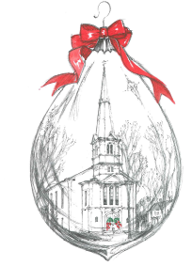

CHRISTMAS EVE SERVICES

On December 24th, there will be two Christmas Eve services, 5:00 pm and 10:00 pm.

The 5:00 pm service will be geared for families with children. The music will include the Junior Choir as well as all of your favorite Christmas hymns. We will also have youth read the nativity story which will be complimented by a visual presentation. (If your child is interested in reading, please send an email to Heather at ssfaithful@ucc.necoxmail.com

The 10:00 pm candlelight service will feature ancient lessons and carols including the Adult Choir and special music.

THERE IS NO
CHURCH SERVICE ON CHRISTMAS DAY

CHRISTMAS POINSETTIA ORDER FORM
Traditionally, members and friends of the United Congregational Church have donated poinsettias in memory of loved ones for our Christmas Eve Services. Please fill in the following for the wording in the bulletin:
Please print clearly.

Given by: _______________________________________________________________________________________

In loving memory of: ______________________________________________________________________________

In celebration of: : ________________________________________________________________________________

In honor of:_____________________________________________________________________________________

Number of plants _____ @ $9.00 each. Total _______
Please make checks payable to: United Congregational Church
Indicate below if you will take your poinsettia or leave it for the Visiting Committee to distribute.
IMPORTANT ~~ PLEASE CHECK ONE:
□ I will take my plant □ Please give my plant away
If no boxes are checked, we will assume that you are not taking them.
All poinsettias may be taken after the Christmas Eve service you attend.
DEADLINE: Orders must be received by December 17th.

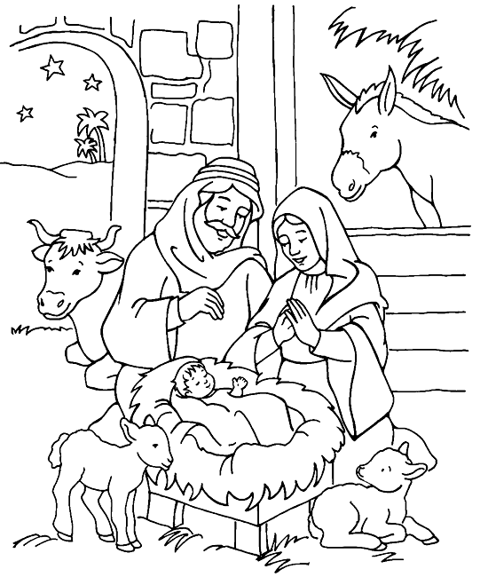

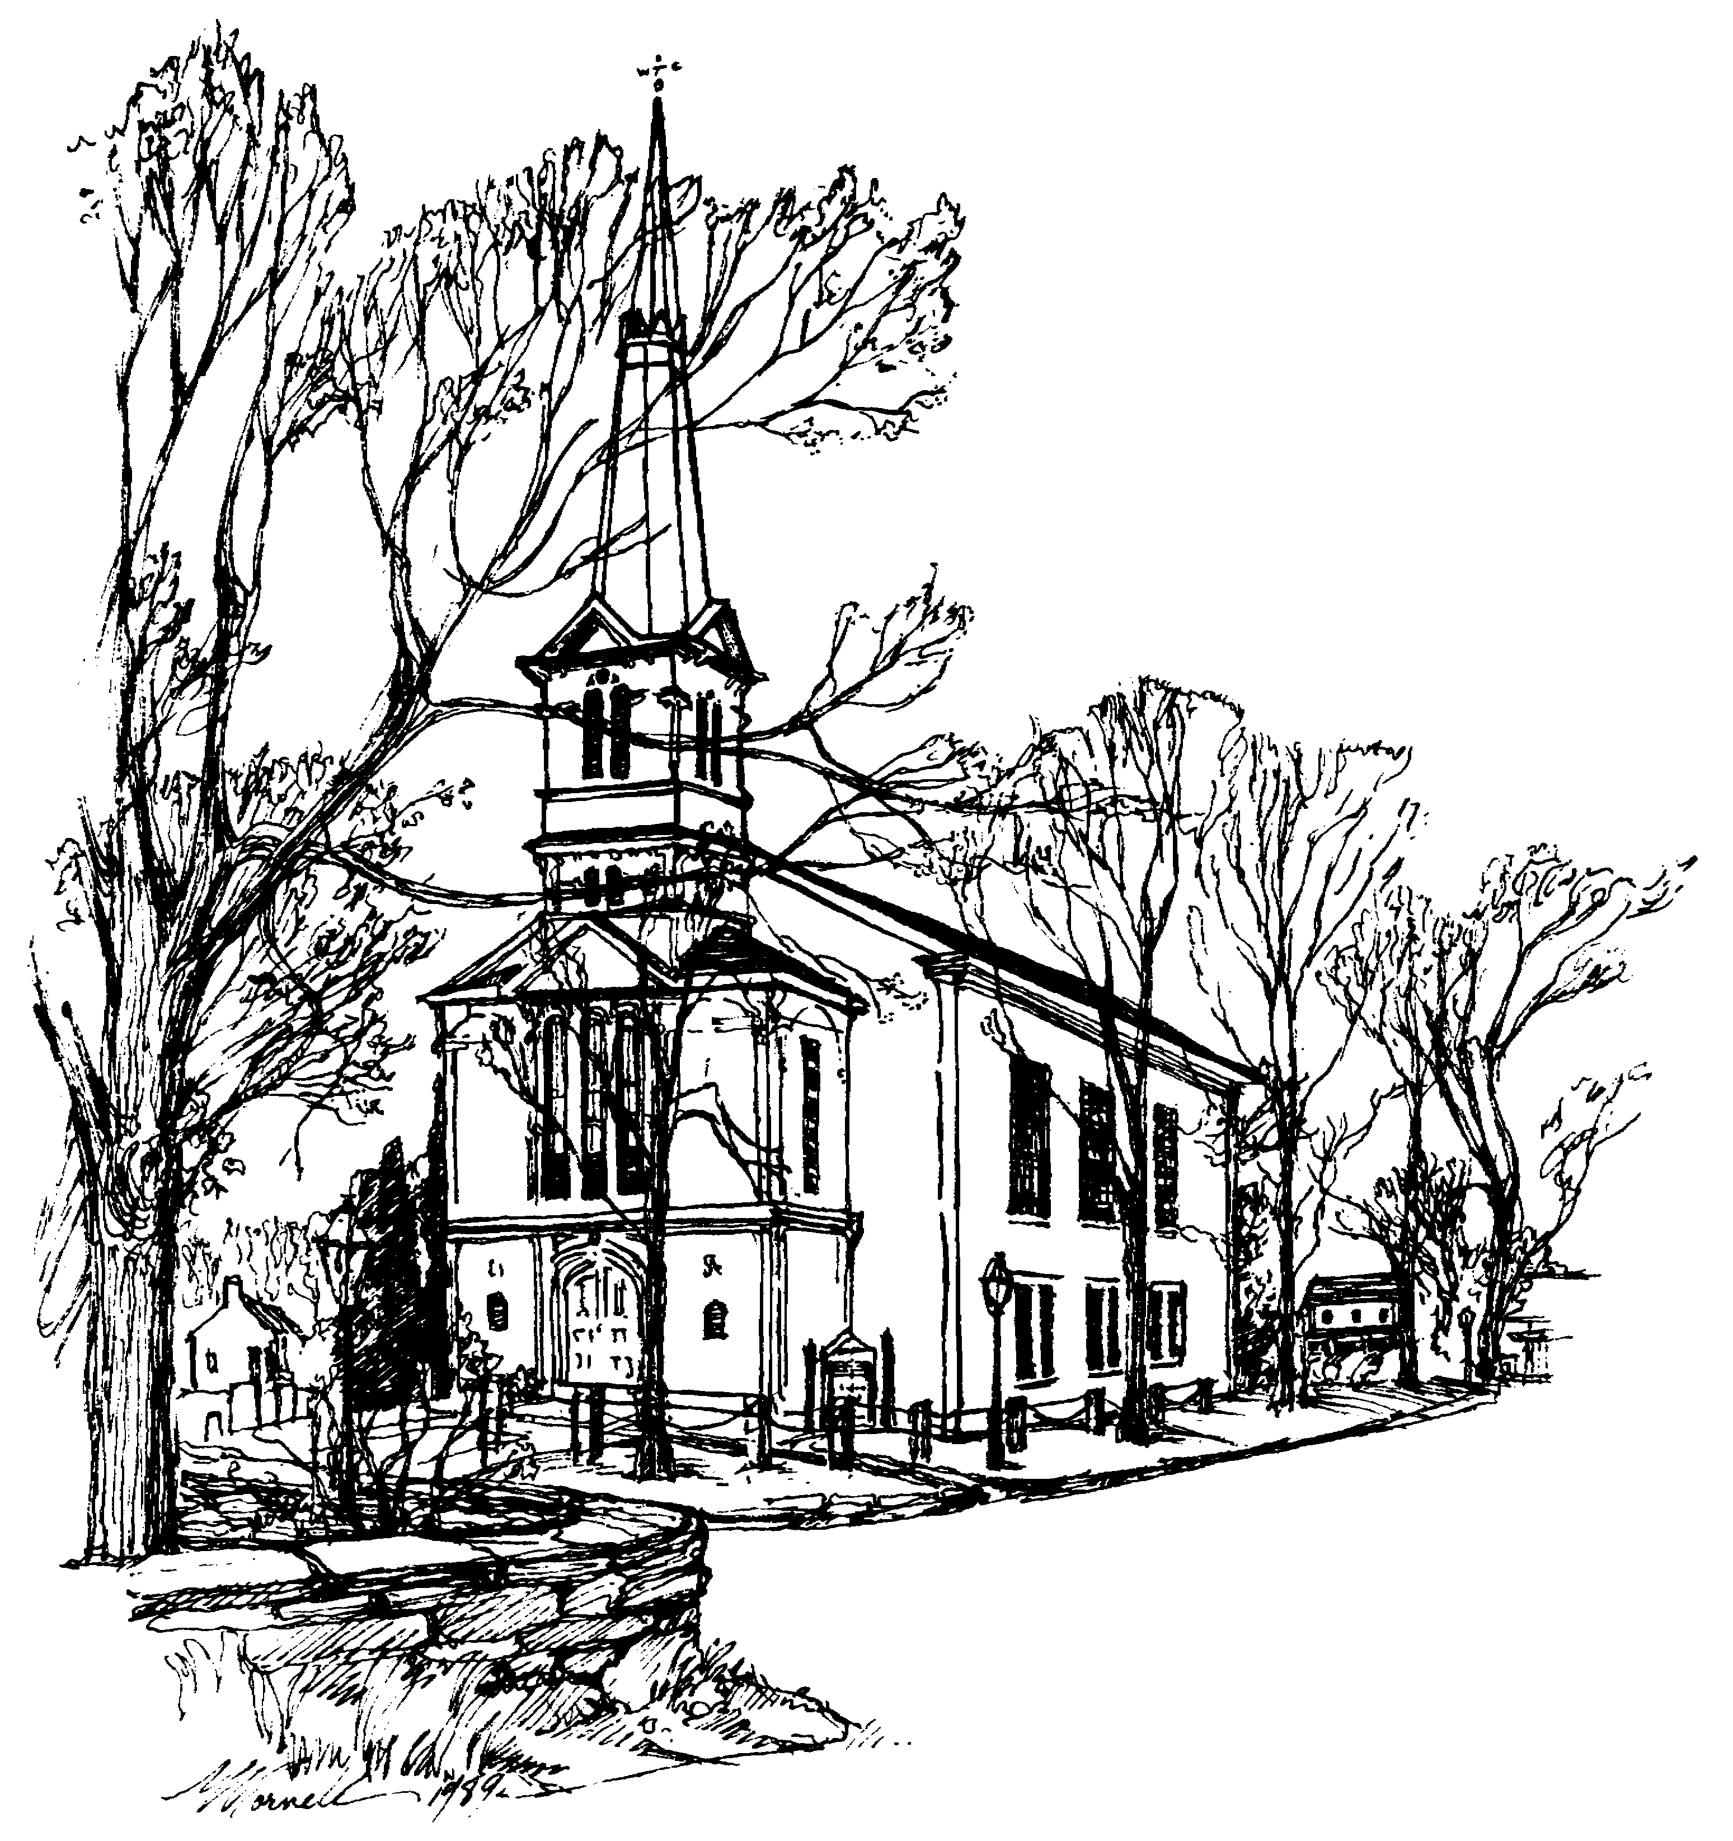 | UNITED CONGREGATIONAL CHURCH  The Commons  P.O. Box 506  Little Compton, RI 02837  Return Service Requested

Merry Christmas! 

UNITED CONGREGATIONAL CHURCH STAFF
Tele: 401-635-8472 Fax: 401-635-8473
Website: www.ucclcri.org

Senior Minister Rev. Rebecca Floyd Marshall revrebecca@ucc.necoxmail.com
Church Secretary Dawn Ross dawn@ucc.necoxmail.com
Church Bookkeeper Maureen Cook bookkeeper@ucc.necoxmail.com
Director of Children & Youth Heather Helger ssfaithful@ucc.necoxmail.com
Music Director Michael Bahmann
Junior Choir Director Stephanie Derbyshire vtderby1@cox.net
Service Coordinators Janet Lofsky janetlofsky@aol.com
Karen Carneal Kcarneal7@cox.net

DECEMBER 2015
Sunday | Monday | Tuesday | Wednesday | Thursday | Friday | Saturday
29  ADVENT WREATH MAKING after Worship service  FIRST SUNDAY OF ADVENT  10:00 AM Worship Service  11:15 AM Shawl Ministry | 30 | 1  No Adult Choir rehearsal tonight | 2    11:30 AM Staff Meeting | 3    There will be no Religious Ed Meeting this month  3:00 PM Junior Choir Rehearsal  4:30 PM Pageant Practice | 4 | 5    9:30 AM Adult Choir Rehearsal
6  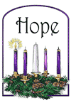  Communion Sunday  SECOND SUNDAY OF ADVENT  10:00 AM Worship Service  11:15 AM Bell Choir Rehearsal  11:15 AM Pageant Practice  11:15 AM Shawl Ministry  11:30 AM Health & Wellness Meeting | 7 | 8  6:00 PM Bell Choir  7:00 PM Adult Choir | 9 | 10    3:00 PM Junior Choir Rehearsal  4:30 PM Pageant Practice  6:00 PM Deacons Meeting | 11 | 12
13  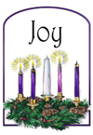  THIRD SUNDAY OF ADVENT  10:00 AM Worship Service  11:15 AM Pageant Practice  11:15 AM Shawl Ministry  11:15 AM Youth Group Christmas Party | 14 | 15    10:00 AM Visiting Committee Mtg.  6:30 PM Finance Committee Mtg.  7:00 PM Adult Choir | 16    6:30 PM Trustees Meeting | 17  3:00 PM Junior Choir Rehearsal  4:30 PM Pageant Practice | 18 | 19  Christmas Pageant Dress Rehearsal - Time TBD
20    CHILDREN'S CHRISTMAS PAGEANT  FOURTH SUNDAY OF ADVENT  10:00 AM Worship Service  11:15 AM Shawl Ministry  3:00 PM Christmas Caroling | 21  9:00 AM Organ Tuning | 22  9:00 AM Organ Tuning  7:00 PM Adult Choir | 23  9:00 AM Organ Tuning | 24    CHURCH OFFICE CLOSED  5:00 PM Christmas Eve Service  10:00 PM Christmas Eve Service | 25    CHURCH OFFICE CLOSED | 26
27  10:00 AM Worship Service  11:15 AM Shawl Ministry | 28 | 29  CHURCH OFFICE CLOSED | 30  CHURCH OFFICE CLOSED | 31    CHURCH OFFICE CLOSED | 1  CHURCH OFFICE CLOSED | 2

JANUARY 2016
Sunday | Monday | Tuesday | Wednesday | Thursday | Friday | Saturday
27  10:00 AM Worship Service  11:15 AM Shawl Ministry | 28 | 29  CHURCH OFFICE CLOSED | 30  CHURCH OFFICE CLOSED | 31  CHURCH OFFICE CLOSED | 1    CHURCH OFFICE CLOSED | 2
3    Communion Sunday  No Sunday School  10:00 AM Worship Service  11:15 AM Shawl Ministry | 4 | 5  7:00 PM Adult Choir | 6 | 7    3:00 PM Junior Choir Rehearsal  7:00 PM Religious Ed Meeting | 8 | 9
10    10:00 AM Worship Service  11:15 AM Shawl Ministry  11:15 AM Youth Group | 11 | 12  10:30 AM Staff Meeting & Luncheon  7:00 PM Adult Choir | 13 | 14  3:00 PM Junior Choir Rehearsal  6:00 PM Deacons Meeting | 15 | 16
17    Gospel Sunday - All Ages Worship  No Sunday School  10:00 AM Worship Service  11:15 AM Shawl Ministry | 18 | 19  10:00 AM Visiting Committee Meeting  6:30 PM Finance Meeting  7:00 PM Adult Choir | 20  6:30 PM Trustees | 21  3:00 PM Junior Choir Rehearsal | 22 | 23
24  10:00 AM Worship Service  11:15 AM Shawl Ministry  11:15 AM Youth Group | 25 | 26  7:00 PM Adult Choir | 27 | 28  3:00 PM Junior Choir Rehearsal | 29 | 30
31    10:00 AM Worship Service  11:15 AM Shawl Ministry | 1 | 2 | 3 | 4 | 5 | 6

