The Church Bell

United Congregational Church
The Commons
P.O. Box 506
Little Compton, RI 02837
Telephone 401-635-8472
Fax 401-635-8473
Office Hours:
Tues – Fri, 9 AM – 3 PM

Worship Service:
Sundays at 10 AM

Email: dawn@ucc.necoxmail.com
Web Site: UCCLCRI.org


2015

INSIDE THIS ISSUE

Chiming In…A message from Rev. Rebecca

Committee News

Bells Are Ringing…(Baptisms,
Weddings, Passings)

Did You Know?

A Blast from the Past

Sweet Butter Recipe

Bible Trivia

Children’s Craft and Puzzle

What’s Happening? November/December Calendar

Chiming in…

Dear Brothers and Sisters of United Congregational Church,

A few weeks ago, our Sunday School kids explored the word “Holy” by repeating in hushed voices, “wow.” By this definition, I believe that holy ground is all around us. Surrounded by honey light filtering through trees all aflame with color, what can we do but say in awe, “wow?” Feeling the amazing energy during Sunday morning worship, watching people pray for each other and care for each other, hearing our youngest members learn about God, what can we do but look around and say with child-like wonder, “wow?”

We are indeed blessed. There is much to fill us with gratitude. But gratitude, like so many things in life, has to be cultivated and tended in order to flourish. In our fast-paced world with its ceaseless demands, it is easy to fly through life taking things for granted. It is easy to miss the wow moments. It is easy to forget to thank God for each amazing one.

Author Ann Lamott says that there are only really three prayers in life-- Help, Thanks, and Wow. It seems that in general, I spend a lot more time on the first one and not so much time on the second two. And yet, when I actually take time to stop and look at my life--there are so many reasons to pray those last two. So this month, in this season of Thanksgiving, I am going to cultivate gratitude. I’m going to try to set aside a little time every day, even if it’s two minutes, and revel in my blessings. I’m going to seek the “wow” moments and savor them. And I’m going to remember to say “Thanks, God.” I invite you to join me and we can see together where it leads us.

Grace and Peace,

Rev. Rebecca Floyd Marshall

~IMPORTANT~

If you have a pastoral emergency, you may call Deacon Debbie Kelchner at
401-524-2007 and/or Rev. Rebecca Floyd Marshall, who can receive messages at the church office (635-8472) or via email at revrebecca@ucc.necoxmail.com.

BOARD AND
COMMITTEE NEWS

For more information on any of the following committees, please contact the church office at
635-8472 or email Dawn at dawn@ucc.necoxmail.com

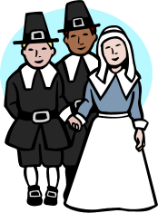

THANKSGIVING DAY COMMUNITY SERVICE
THURSDAY, NOVEMBER 26th

Please join us for a traditional service held at the Friends Meeting House on 234 West Main Road, Little Compton at
10:00 am.

St. Andrew’s joins the United Congregational Church in leading the service.

Please dress warmly

Board of
Deacons

Catherine Sawoski & Richard McGee

The Youth Deacons, on behalf of the Board of Deacons, would like to extend a warm welcome to Reverend Rebecca. This is a very exciting time for our church community. Everyone looks forward to having Reverend Rebecca with our church for a long time. The Deacons wish Reverend Rebecca peace and joy in her new guiding role as our pastor.

New Youth Deacons Introduction

At the Deacons meeting this October, two new faces could be seen sitting at the board table, observing and learning. On November 1st, 2015 the term of Youth Deacons Catherine Sawoski and Richard McGee officially begin, where they will attend meetings, help advise the church, read verses at sermons, and serve communion. Their confirmation was just this last year, in May, along with four other teens in what was the smallest class in years.

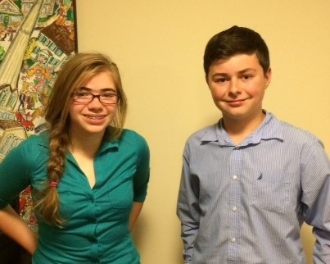

There has never been a time that Catherine hasn’t been a part of the church, since she was baptized in 2002 by Pastor Rich, having fond memories of children’s messages and Christmas Pageants. The church has always meant the world to her and she can keenly feel the sense of community every time she walks through the doors on Sundays. Ever since she joined youth group two years ago -- continuing working with as a part of to this day, recently hosting a dinner for The Circle of Friends -- and her brother, Matthew Sawoski, was appointed the youth deacon for his year, she had been looking forward to the opportunity to represent the youth in this position, with many ideas for the benefit of the church.

She is a writer at heart (having recently published a novella, and writing in any free time) and her favorite pastime being reading classics like those of John Steinbeck and F. Scott Fitzgerald. Her mother and father have been incredibly influential in her life, mentally and spiritually: her father, Mark Sawoski, being raised Catholic, and mother, Sue Eckert, Methodist. This, with an awareness of other cultures and current events (her father being a professor of International Relations) has deepened her understanding and contributed to the fundamental idea that has based much of her religious beliefs, that all thoughts regarding everyone’s
relationship with God are equally right. Catherine attends eighth grade at the Wheeler School in Providence, RI, and is currently thirteen years old. Little Compton is and always will be her home, as she lives near the Sakonnet with her family, including her Golden Retriever, Kaycee.

Richard McGee is thirteen years old and in eighth grade. He is home schooled and lives on a small farm in Little Compton. He likes animals and wants to be a veterinarian. He enjoys taking care of his two dogs, two cats, a horse, and four cows. His other hobbies include riding his bicycle, golf, basketball, walking in the woods, reading and writing stories, news and current events, and working with his dad around the farm. Richard very much appreciates being a church member and completed his confirmation last year. He enjoys youth group events, especially being friends with the other youth. He also likes doing readings and attending Christmas Eve services. One of the things Richard has learned to appreciate most is the kindness and comfort offered by the church community. Recently during Reverend Rebecca's second sermon, she spoke about loss and how important it is to comfort and support families in our church during difficult times. Those words brought peace and comfort to Richard and his family during a very sad time following the death of his grandmother. Richard looks forward to learning about the role of a deacon in our church and hopes to do his part to make meaningful contributions.

Both of these two teenagers are excited to embrace their role in the church community, and are beyond honored to be selected for such an important task. They are confident that they can do their duties with precision and dedication, looking forward to learning all they can. Richard and Catherine are eager to walk into the doors of the United Congregational Church this Sunday as the new Youth Deacons, and to feel the community once more.

QUARTERLY
MEETING

Shirley Hardison, Clerk,

United Congregational Church
Quarterly Meeting
Sunday, November 22, 2015
Following Worship Service

WARRANT

Members of the United Congregational Church in Little Compton are hereby warned of the Quarterly Meeting of said church to be held on Sunday, November 22, 2015 in the sanctuary of the church immediately following the service. The purpose of said meeting will be:

●Plans for Pastor Rebecca’s
installation
●Trustees:
○ The Parsonage
○ Steeple lease to A T & T
○ Utility easement over
church property
●Board of Deacons:
○ Updates to church use
brochures (weddings and
funerals)
○ Pew literature updates
●Committee Reports
●Quarterly Financial Update
●New Business

Bells are ringing…

Weddings
Our congratulations to:

Orrin John Hanratty III &
Hannah Schofield
Married October 10, 2015.

Board of Trustees

Tom Schmitt, Chair

Parsonage\ ‘par-snij,\ n: a house provided by a church for its pastor.

Although our pastor has not lived there since the early years of Richard DenUyl’s tenure, we have a parsonage. It is the large white building across from the church at the corner of Commons and South of Commons Road, next to the Thrift Shop. Until recently we’ve been renting it. Several weeks ago, after our tenants moved, Peter Derbyshire, chair of the Buildings and Grounds Committee, ordered a property inspection to d etermine its condition. Although that report cited no major structural problems, it did reveal several challenges. A deteriorated bulkhead was welcoming rainwater into the crawl space (the dwelling has no cellar). Wooden gutters and the trim boards to which they are fastened had rotted in several places. Mold and mildew in a first floor corner room led us to damaged heating pipes.

Although Trustees are eager for the parsonage to be a source of income, we delayed re-renting it to assess the building’s condition, give it a good scrubbing and repair its most serious flaws. Work accomplished so far includes replacement of the leaking bulkhead, mold and mildew abatement, selected interior painting, heating system repairs and gutter replacement in several areas. We’re also pondering the possibility of waterproofing the crawl space and installing a dehumidifier. By early 2016 we hope a new neighbor is calling the parsonage “home.”

The merger of separate 1800s structures that carpenters put together on its current site, our parsonage is an important church asset. But its deferred maintenance list is long and daunting. We wonder, too, whether the parsonage could be put to some other church use. These are two of the questions Trustees expect to address in 2016. To familiarize members with that building and prepare for discussion about its future, we are planning a post-service coffee there in November. The parsonage will also be a topic of discussion at our November quarterly meeting.

Finance Committee

Bob Hartnett, Chair

It is wonderful to witness all the excitement these days while attending Church. Seeing everyone enjoying the Sunday services, looking forward to hearing Reverend Rebecca's sermons is what it is all about. With the increase in attendance we have finally turned the corner and are headed just where we had hoped for. With the annual pledge campaign about to begin, the timing is perfect and Finance is looking forward to what should be a great 2016.

Let us pray.

Flower Committee

Holly Billings, Chair

The Flower Committee is looking for a new monthly chairperson to see to the flowers in the church for the month of September. It is really easy and rewarding! Give me a call and I can explain the process. If you are interested in donating flowers, at any time, please see Holly Billings after church or contact her at 635-2451 or hgbillings@gmail.com

Health & Wellness Ministry / Shawl Ministry

Wendy Merriman

I wrote a piece for this newsletter several months ago. I feel it is time to mention three words we use that we can become aware of again!

How often do we use or hear someone say “BUT”

“My husband went to the doctor today BUT I got lost in traffic on the way home.”

“I haven’t been feeling well BUT there is so much to do.”

“I wanted to come to church today “BUT” my car would not start.”

Can we replace “BUT” with an “AND”?

In my class with Parish Nurses we called it Awareness, Process, Mystery. When we become aware of a word we use often and then replace it…amazing things can happen!

Two other words I tried to teach students not to use. One is JUST…one does not JUST do anything. The word negates what you have done. “I JUST won the lottery!”

The last is SHOULD…as part of our health and wellness ministry, may we all take the SHOULDS out of our lives. The SHOULDS take up so much energy. What can we replace the SHOULD with? The next time you use the word catch yourself and think about what you could have said.

Answers in next Newsletter!

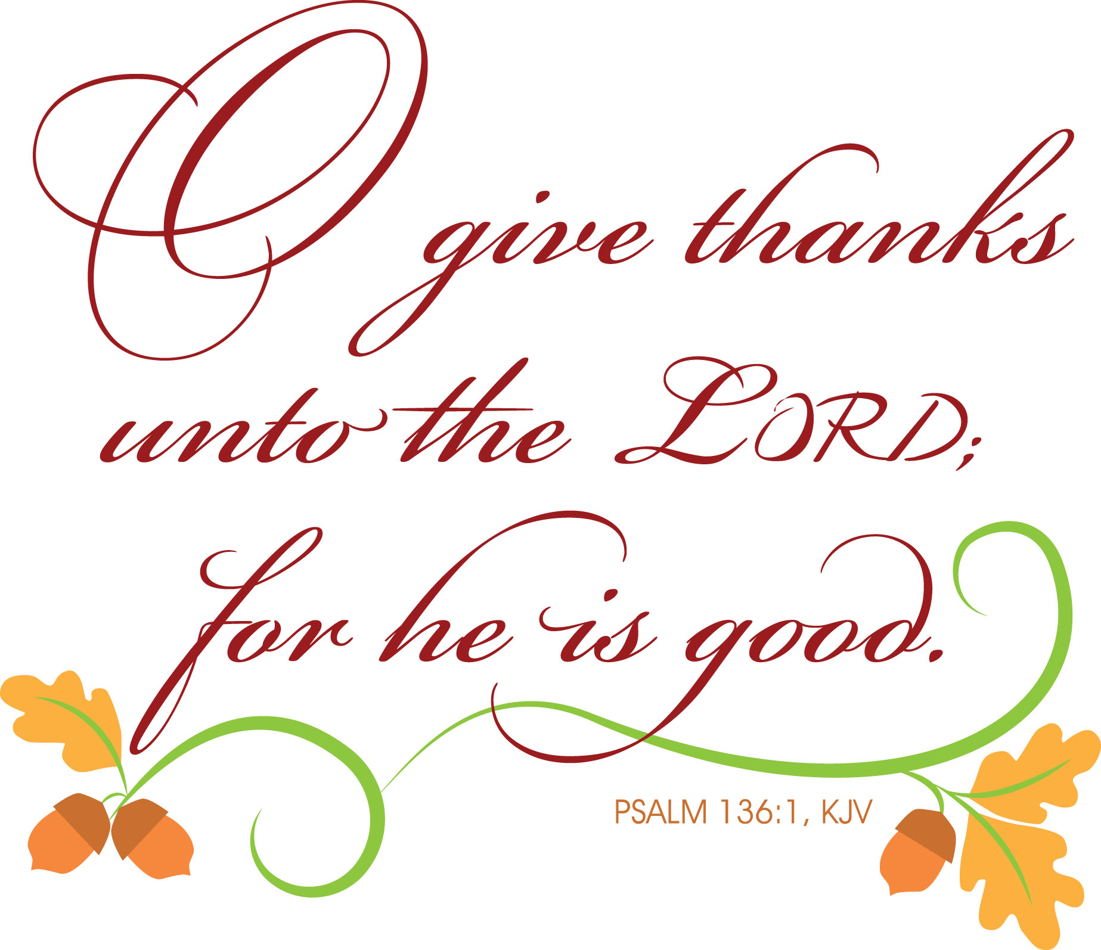

Sunday School

Heather Helger
Director of Children & Youth

S.S. Faithful

October proved to
be a busy month for
Sunday School. The month began with another All-Ages worship to celebrate World Communion Sunday. Children paraded into the sanctuary during the opening hymn with breads and flags from around the world, which afterwards created a beautiful visual display for the remainder of the service. During the Children’s Message time, youth presented breads in honor of four countries experiencing current life challenges: Mexico, Syria, China and South Sudan all of whom like us had Christians celebrating Communion as we did this day. The next All Ages Service will be held on Nov. 1st as we celebrate All Saint’s Day together!

Two special Sunday School events were held in October. The Ryan Family hosted a ‘Meet & Greet’ with Pastor Rebecca targeted to Sunday School families. What a great turn-out we had for homemade pizza and ice cream sundaes! Hope was an amazing host! We were also hosted by the Johnson Family for a Hayride at Nagetuck Tree Farm on South Lake Road in Tiverton. Afterward we enjoyed yet another pizza dinner and then carved pumpkins that were donated to us by Young Family Farm. Thank-you to the Young Family, for their generous donation! This was a second opportunity for families to meet and greet with Rebecca and Alex.

The Sunday School’s October Rotation story was based on the Plagues/Passover. The children encountered this somewhat theologically challenging story through cooking, games and music workshops. Emphasis was placed on the fact that God needed to take extreme action to convince the most powerful king on the earth at the time to let God’s people go free from slavery and that God gave Pharaoh chance and chance again to make the right decision. Pharaoh was of course stubborn as the Israelite people were a vital part to Egyptian life, hence it taking 10 plagues until Pharaoh caved. When the 10th and final plague “the death of all Egyptian first born son” was blown (Hebrew homes were “Passed Over” because they marked their door with the blood of their finest lamb as God had instructed), Pharaoh and the Egyptians’ begged for the Israelites to leave. They had to flee quickly in the middle of the night with no time for their bread to rise. Our children learned that Jewish people to this day celebrate this story of the Israelites freedom from slavery at Passover and by eating unleavened bread. The children were reminded that it was a Passover feast at which Jesus ate his Last Supper and had the First Communion which we continue to do in his remembrance today. In November, the children will continue with the Exodus story as they learn about the next part of the story, the Parting of the Red Sea.
Children had a practice fire drill in October so they are prepared for exiting the building in the case of an emergency. This is part of our “Safe Church Plan for Children & Youth.” As a Halloween gift from the church, children were given “Shine Jesus’ Light” flashlights and a Halloween Prayer with a Candy Corn treat taped to the back.

Upcoming Sunday School dates to note include the Christmas Pageant meeting on November. 15th after church in the Education Building. The title and theme of the pageant will be introduced and children and youth will begin signing up for parts. Also, the 1st Sunday of Advent will be November 29th. This will be an All-Ages service (there will be no Circle Time this Sunday) and there will also be an Advent Wreath Making event open to the entire church congregation after church that day. Anyone interested in making a wreath, must sign-up in advance, so enough materials can be purchased for those attending and there is a request for a $5 donation per wreath to help defer the significant costs of the materials.

The Youth Group again hosted their annual Halloween Outreach Dinner for Circle of Friends this month. On the Friday before the event, the group prepared a dinner of homemade butternut squash soup, salad, lasagna and pumpkin cupcakes for a decorate-your-own cupcake dessert activity. The next day the group dressed in costume to serve the dinner to the Circle of Friends attendees. As always the group received many compliments on their cooking and outstanding food service! Emily & Louise Goodman and Heather continue every year to be so impressed by the youth’s efforts for this event! This is an extremely meaningful weekend for our group every year! The group also had a meeting this month focused around how their faith can help them through the many life stresses they find themselves experiencing due to school, sports & activities, family, etc. They also made plans to paint the Church’s Red Shed as an upcoming project in honor of Stewardship month in November. During the month of November, the group will also be selling homemade apple pies to be delivered the Sunday before Thanksgiving as a fundraiser for a trip to the UCC’s National Youth Event in July 2016. The pies are $15 each and we ask you to please consider purchasing a pie in support of the group’s trip. The youth will clean up Old Stone Apple Orchard on November 1st at 1pm and in return for their service they get fresh apples for use in their pie baking on Sat., November 21st at 3pm. The group will also be helping to assemble the Thanksgiving baskets at the LC Wellness Center Food Bank that will be distributed to local families in need this upcoming holiday on Sat. October 14th at 10am.

During October, Sunday School staff attended two Professional Development trainings. Heather attended the MA & RI Conference Super Saturday along with Rebecca and Shirley Hardison. Heather attended both a Safe Church and Youth Group workshop. Heather and Louise Goodman also attended their first class of a MA EEYM (Education for Effective Youth Ministries) training this month as well.

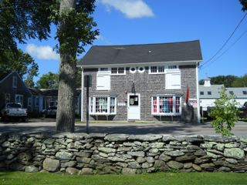

Thursday Thrift Shop
Nancy Webb

It's Fall! And the Thrift Shop is winding down, not taking any more donations and consignments, but we still have lots of clothes and items for sale. The Bag Sale will be on Saturday, November 7 from 10:00AM − 3:00PM. For the low price of $5.00 per bag, you can fill your bags with treasures!

The Thursday Thrift Shop is made possible through the work of church and community volunteers. The annual appreciation luncheon for volunteers is scheduled for November 9th at noon. This year we'll be honoring Past President Virginia Watt for her many years of dedication to the Thrift Shop, as well as others.



Don’t forget to
Turn your
clocks BACK.

Daylight Saving Time ends on
Sunday, November 1ST

Office News



The Church Office will be closed on the following dates in November:

Thanksgiving Day, Thursday, November 26th and on Friday, November 27th. The office will re-open on Tuesday, December 1st.

Please Note: Dawn will be on vacation November 24th & 25th. If there is anything you may need before then, please contact the Church Office.



Sunday, November 1st is All Saints Day, a special celebration in the church of the many Christians who have come before us and on whose great shoulders we stand. One tradition of All Saints Day is to particularly remember the “saints” who are no longer with us, the many loved ones who have passed away. So, please bring with you to church on Nov. 1st a framed photo (no larger than 4X6) of a family member, friend, or mentor whose memory you would like to honor. We will also invite each family up to light a candle in memory of these beloved “saints” who helped shape their lives and faiths

A Blast From the Past!

Marjorie Simmons, Church Historian

Tiverton Scout Journeys to Chile
December 1998 – January 1999

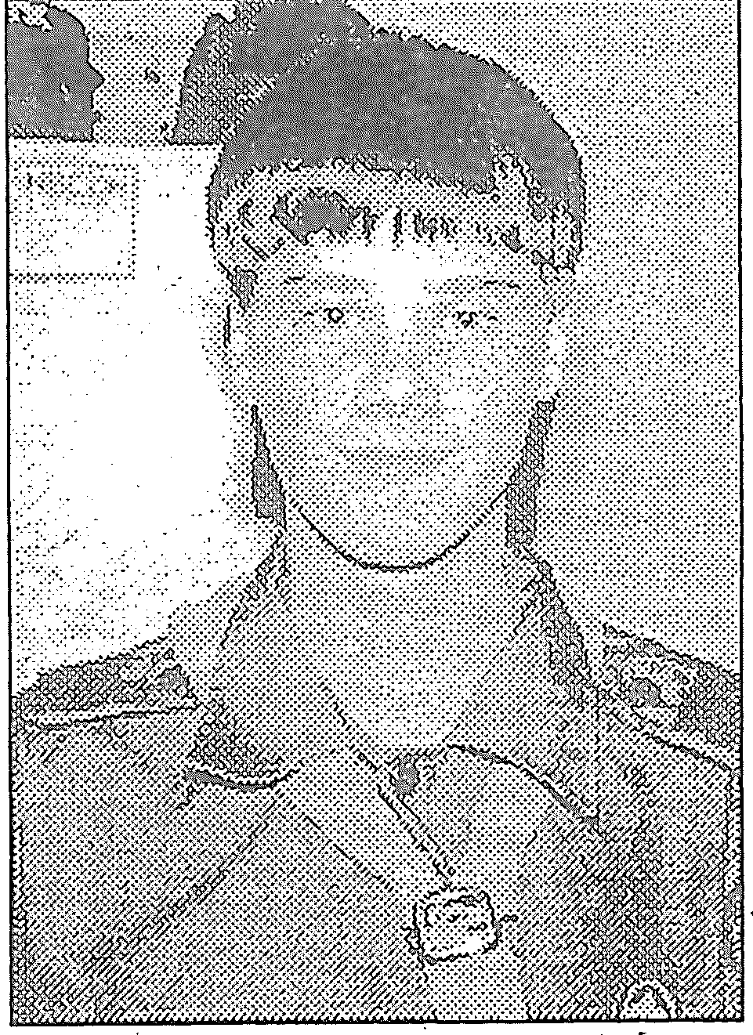
Tiverton High freshman, Chris Croteau welcomed the New Year far from home among 35,000 other young people from around the world who had gathered for the Boy Scouts’ World Jamboree. Chris was the only RI representative.

The entire camp was spread out in the shadow of a mountain range. Within it were some 25 subcamps from different countries, including the UK, France, Italy, Peru, Brazil and Chile. Americans from Idaho, Texas, New Jersey, Maryland, California and other states were there as well. The boys’ ranged in age from 14 to 21.

“My mom got me into it,” said Chris of scouting. “I like camping, I like being outdoors.” Sandi Croteau, a Little Compton native, was a Girl Scout in her younger days, had a brother who went through scouting. She was a cub master and Chris started in her pack.

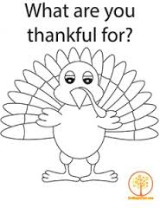



Rhode Island Conference
United Church of Christ
209th Autumnal Meeting!!!

Peace Dale Congregational UCC
261 Columbia Street
Peace Dale, RI 02879
Saturday, November 7, 2015
8:30am - 1:30pm

NO COST TO REGISTER/ FREE LUNCH!

ALL planning to attend must register prior to meeting.
Autumnal Meeting 2015

Come hear about and join in conversation
about how the RI, MA, & CT Conferences of the UCC
might move into the future together!

Check out ricucc.org for more details!
This is a FREE meeting this year!!

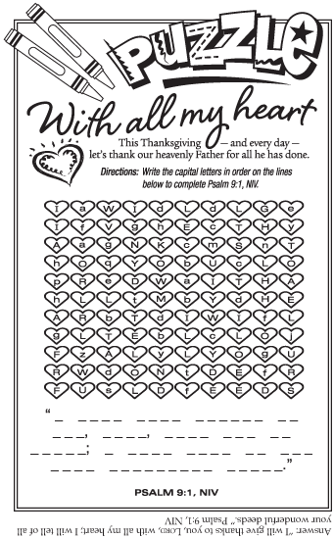
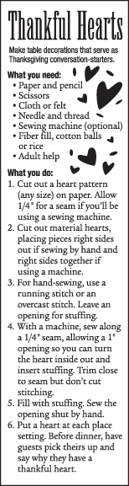

Our deadline for the
December Newsletter is
Tuesday, Nov. 17th.

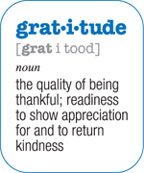

Bible Trivia
Spreading a Feast

How many of the following can you answer? (Answers in next month’s newsletter).

- What king had a feast where a mysterious hand wrote on the wall?
- Who threw a royal feast where his wife disobeyed him?
- Who told a bizarre riddle at his wedding feast?
- What Pharisee had a feast that Jesus attended?
- What city had a wedding feast where Jesus’ first miracle was done?



In all things
give thanks.

~ 1 Thessalonians 5:18

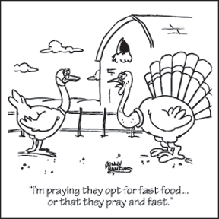

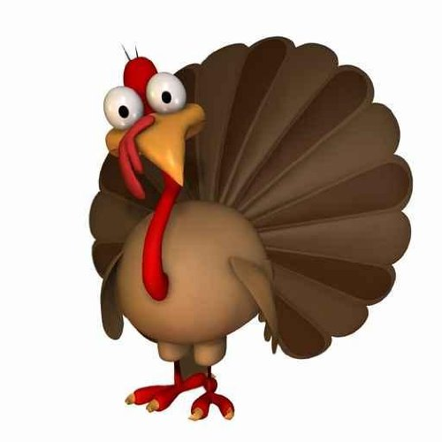
Did you
know?

Wild turkeys can run 20 mph when they are scared.

In the US, about 280 million turkeys are sold for the Thanksgiving celebrations.

Lobster, rabbit, chicken, fish, squashes, beans, chestnuts, hickory nuts, onions, leeks, dried fruits, maple syrup and honey, radishes, cabbage, carrots, eggs, and goat cheeses are thought to have made up the first Thanksgiving feast.

Pilgrims didn’t use forks. They ate with spoons, knives, and their fingers.

The snood (only in males) is the red growth from the forehead over the bill, and the part underneath the throat is the wattle.

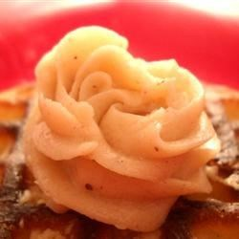
Sweet Butter
(Recipe from Allrecipes.com)

A sweet and spiced, simple to
Make butter spread. Goes perfect on cornbread,
Pancakes, and toast.

1/2 cup softened butter
1/4 cup brown sugar
2 tablespoons of honey
1 pinch ground cinnamon
1 pinch ground nutmeg
1/2 pinch ground ginger

Place the butter into a bowl and stir together with brown sugar, honey, cinnamon, nutmeg, and ginger until the mixture is completely blended.

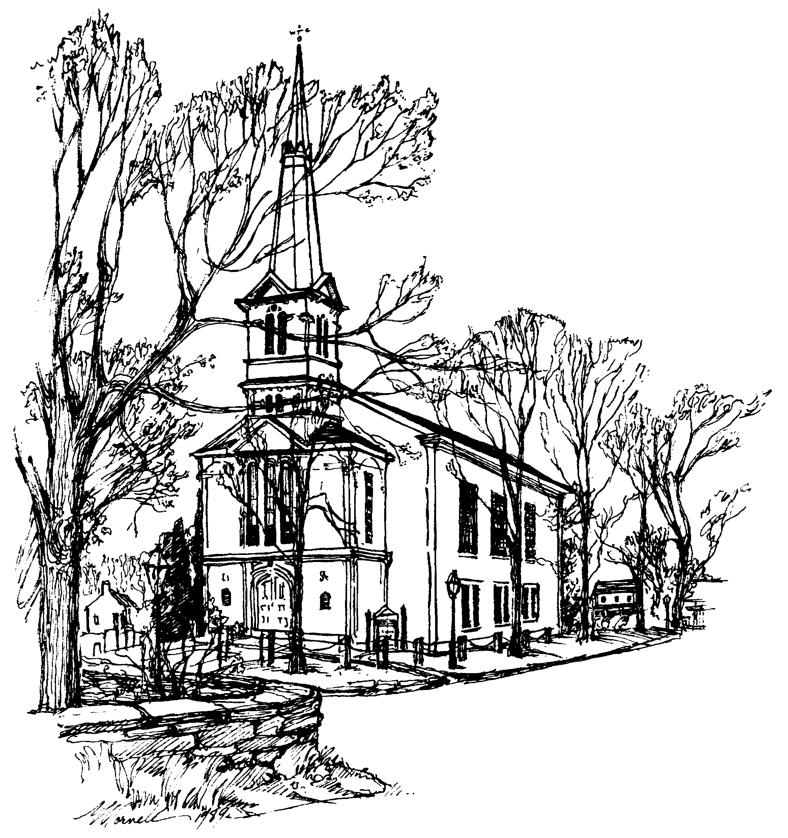 | UNITED CONGREGATIONAL CHURCH  The Commons  P.O. Box 506  Little Compton, RI 02837  Return Service Requested



UNITED CONGREGATIONAL CHURCH STAFF
Tele: 401-635-8472 Fax: 401-635-8473
Website: www.ucclcri.org

Senior Minister Rev. Rebecca Floyd Marshall revrebecca@ucc.necoxmail.com
Church Secretary Dawn Ross dawn@ucc.necoxmail.com
Church Bookkeeper Maureen Cook bookkeeper@ucc.necoxmail.com
Director of Children & Youth Heather Helger ssfaithful@ucc.necoxmail.com
Music Director Michael Bahmann
Junior Choir Director Stephanie Derbyshire vtderby1@cox.net
Service Coordinators Janet Lofsky janetlofsky@aol.com
Karen Carneal Kcarneal7@cox.net

NOVEMBER 2015
Sunday | Monday | Tuesday | Wednesday | Thursday | Friday | Saturday
  1  ALL SAINTS SUNDAY  Communion Sunday  Daylight Saving Time ends  10:00 AM Worship Service  11:15 AM Shawl Ministry  1:00 PM YG Apple Orchard Clean-up (Old Stone Orchard) | 2 | 3    11:30 AM Staff Meeting  7:00 PM Adult Choir | 4 | 5    3:00 PM Junior Choir  7:00 PM Religious Ed Mtg. | 6 | 7    THRIFT SHOP CLOSES FOR THE SEASON  8:00 AM RICUCC Autumnal Meeting at Peace Dale Congregational
8    10:00 AM Worship Service  11:15 AM Shawl Ministry  11:15 AM YG Painting Red Shed Stewardship Project | 9  12:00 PM Thrift Shop Luncheon in Vestry | 10    11:30 AM Staff Luncheon  7:00 PM Adult Choir | 11   | 12    3:00 PM Junior Choir  6:00 PM Deacons Mtg. | 13 | 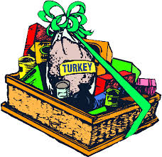  14  10:00 AM YG Thanksgiving Basket Assembly Outreach Project @ LC Wellness Center Food Bank
15    10:00 AM Worship Service  11:15 AM Shawl Ministry  10:00 AM Christmas Pageant Meeting | 16 | 17    No Adult Choir Rehearsal  tonight  NEWSLETTER DEADLINE  10:00 AM Visiting Comm. Mtg.  6:30 PM Finance Mtg. | 18 | 19    3:00 PM Junior Choir | 20 | 21    3:00 PM YG Apple Pie Baking @ Amicable Church
22    QUARTERLY MEETING  THANKSGIVING SUNDAY  10:00 AM Worship Service  11:15 AM Shawl Ministry  11:15 AM Youth Group | 23 | 24  No Adult Choir Rehearsal  tonight | 25    6:30 PM Trustees Mtg. | 26    CHURCH OFFICE CLOSED  10:00 AM THANKSGIVING DAY SERVICE at Friend's Meeting House, 234 West Main Road, Little Compton | 27  CHURCH OFFICE CLOSED | 28
29    ADVENT WREATH MAKING after Worship service  FIRST SUNDAY OF ADVENT  10:00 AM Worship Service  11:15 AM Shawl Ministry | 30 | 1  No Adult Choir rehearsal tonight  11:30 AM Staff Meeting | 2 | 3  3:00 PM Junior Choir Rehearsal  7:00 PM Religious Ed Meeting | 4 | 5

DECEMBER 2015
Sunday | Monday | Tuesday | Wednesday | Thursday | Friday | Saturday
29  ADVENT WREATH MAKING after Worship service  FIRST SUNDAY OF ADVENT  10:00 AM Worship Service  11:15 AM Shawl Ministry | 30 | 1  No Adult Choir rehearsal tonight  11:30 AM Staff Meeting | 2 | 3  3:00 PM Junior Choir Rehearsal  7:00 PM Religious Ed Meeting | 4 | 5
6    Communion Sunday  SECOND SUNDAY OF ADVENT  10:00 AM Worship Service  11:15 AM Shawl Ministry  11:30 AM Health & Wellness Meeting | 7 | 8    7:00 PM Adult Choir | 9 | 10  3:00 PM Junior Choir Rehearsal  6:00 PM Deacons Meeting | 11 | 12
13    THIRD SUNDAY OF ADVENT  10:00 AM Worship Service  11:15 AM Shawl Ministry  11:15 AM Youth Group | 14 | 15  10:00 AM Visiting Committee Mtg.  6:30 PM Finance Committee Mtg.  7:00 PM Adult Choir | 16 | 17  3:00 PM Junior Choir Rehearsal | 18 | 19
20    CHILDREN'S CHRISTMAS PAGEANT  FOURTH SUNDAY OF ADVENT  10:00 AM Worship Service  11:15 AM Shawl Ministry  3:00 PM Christmas Caroling | 21  Organ Tuning | 22  Organ Tuning  7:00 PM Adult Choir | 23  Organ Tuning  6:30 PM Trustees Meeting | 24    CHURCH OFFICE CLOSED  5:00 PM Christmas Eve Service  10:00 PM Christmas Eve Service | 25    CHURCH OFFICE CLOSED | 26
27  10:00 AM Worship Service  11:15 AM Shawl Ministry | 28 | 29  CHURCH OFFICE CLOSED  7:00 PM Adult Choir | 30  CHURCH OFFICE CLOSED | 31    CHURCH OFFICE CLOSED | 1  CHURCH OFFICE CLOSED | 2

